ENGLAND AND THE LOW COUNTRIES, 1336-1500: PRICES AND WAGES

Consumer Price Indexes, Nominal Wage Indexes, Real Wage Indexes:

RWI = NWI/CPI

Figure 1

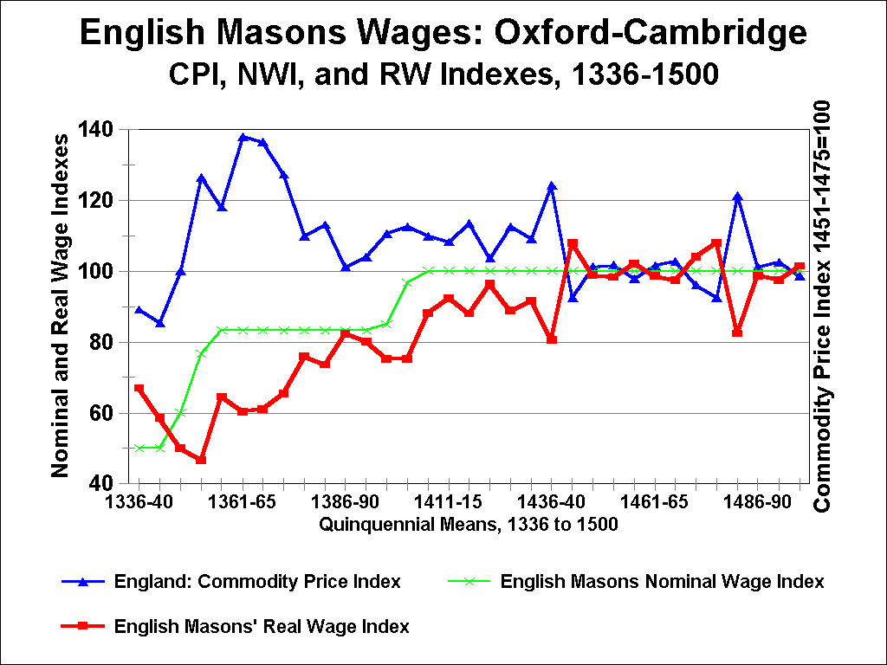

ENGLAND AND THE LOW COUNTRIES, 1336-1500: PRICES AND WAGES

Consumer Price Indexes, Nominal Wage Indexes, Real Wage Indexes:

RWI = NWI/CPI

Figure 2

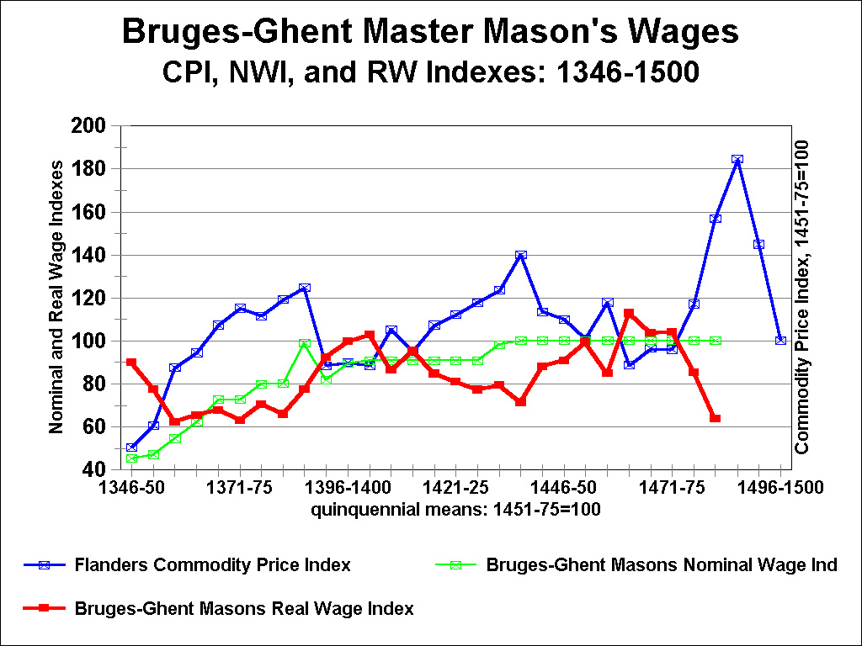

ENGLAND AND THE LOW COUNTRIES, 1336-1500: PRICES AND WAGES

Consumer Price Indexes, Nominal Wage Indexes, Real Wage Indexes:

RWI = NWI/CPI

Figure 3

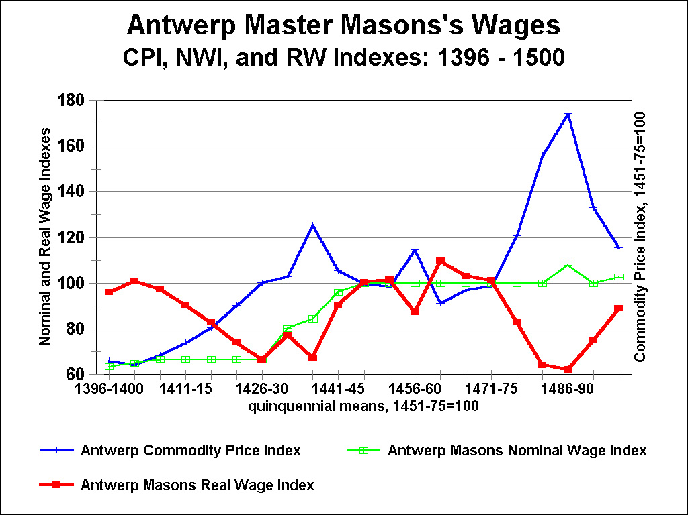

ENGLAND AND THE LOW COUNTRIES, 1336-1500: PRICES AND WAGES

Consumer Price Indexes, Nominal Wage Indexes, Real Wage Indexes:

RWI = NWI/CPI

Figure 4

