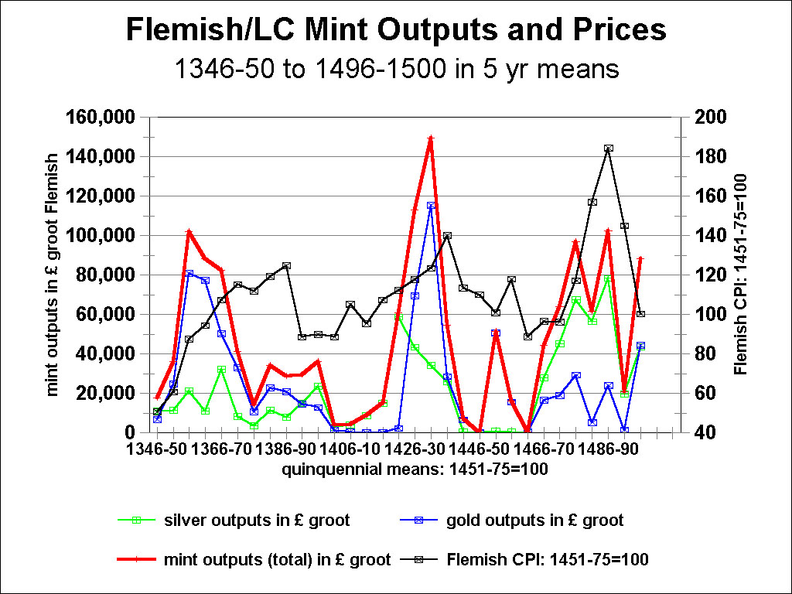

Figure 1: The Relationships between Mint Outputs (in current moneys-of-account) and Prices in Flanders and the Burgundian Low Countries: from 1346-50 to 1496-1500, in quinquennial means

Sources: John Munro, “Wage-Stickiness, Monetary Changes, and Real Incomes in Late-Medieval England and the Low Countries, 1300 - 1500: Did Money Matter?,” Research in Economic History, 21 (2003), Tables and Figures, pp. 231-69; John Munro, “Builders’ Wages in Southern England and the Southern Low Countries, 1346 -1500: A Comparative Study of Trends in and Levels of Real Incomes,” in Simonetta Cavaciocchi, ed., L’Edilizia prima della rivoluzione industriale, secc. XIII-XVIII, Atti delle “Settimana di Studi” e altri convegni, no. 36, Istituto Internazionale di Storia Economica “Francesco Datini” (Florence: Le Monnier, 2005), Tables and Figures, pp. 1048-76.
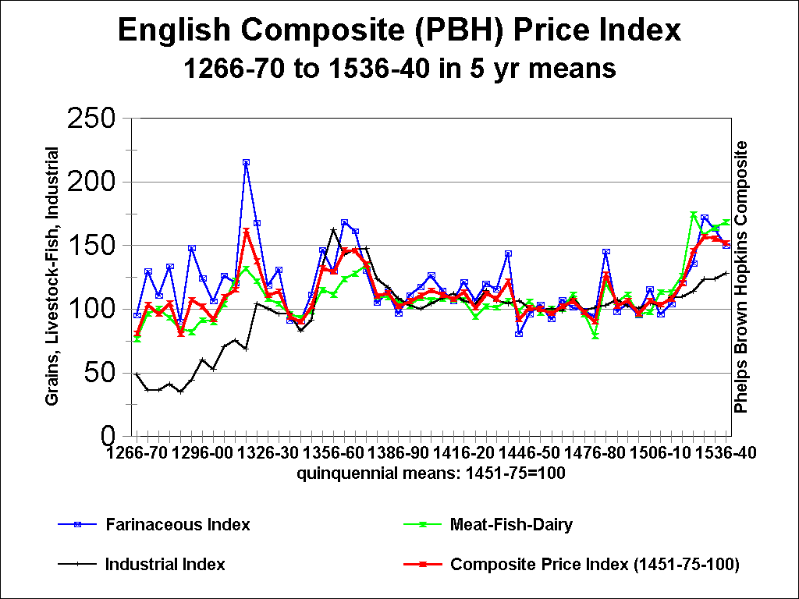

Figure 2: The Phelps-Brown and Hopkins Composite Price Index for England: from 1266-70 to 1536-40, in quinquennial means: index base: mean of 1451-75 = 100

Sources: E. H. Phelps Brown and Sheila V. Hopkins, “Seven Centuries of the Prices of Consumables, Compared with Builders’ Wage Rates,” Economica, 23:92 (November 1956), 296-314; reprinted in E.H. Phelps Brown and Sheila V. Hopkins, A Perspective of Wages and Prices (London, 1981), pp. 13-59, with price indexes for five commodity groups not given in the original publication.

Their annual price data was corrected from their own working papers in: The Archives of the British Library of Political and Economic Science (Robbins Library), the Phelps Brown Papers Collection: in Boxes Ia.324 and J.IV.2a..

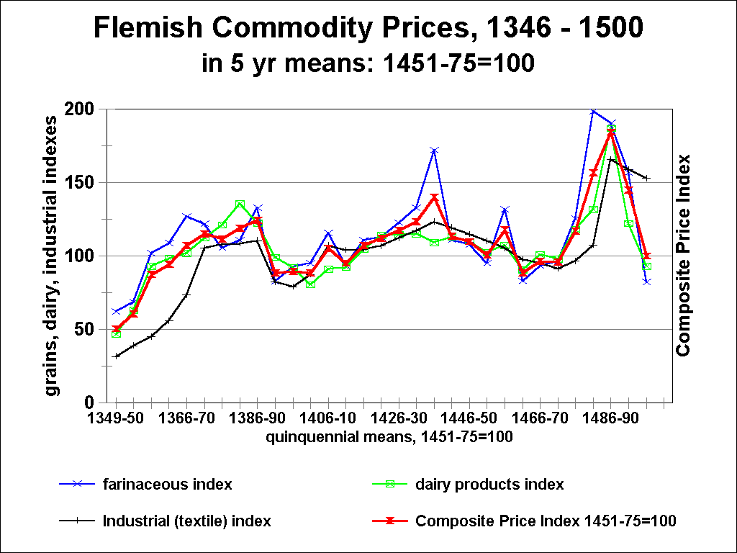

Figure 3: The Composite Price Index for Flanders, from 1346-50 to 1496-1500, in quinquennial means. Index base: mean of 1451-75 = 100.

See the sources for Figure 1.
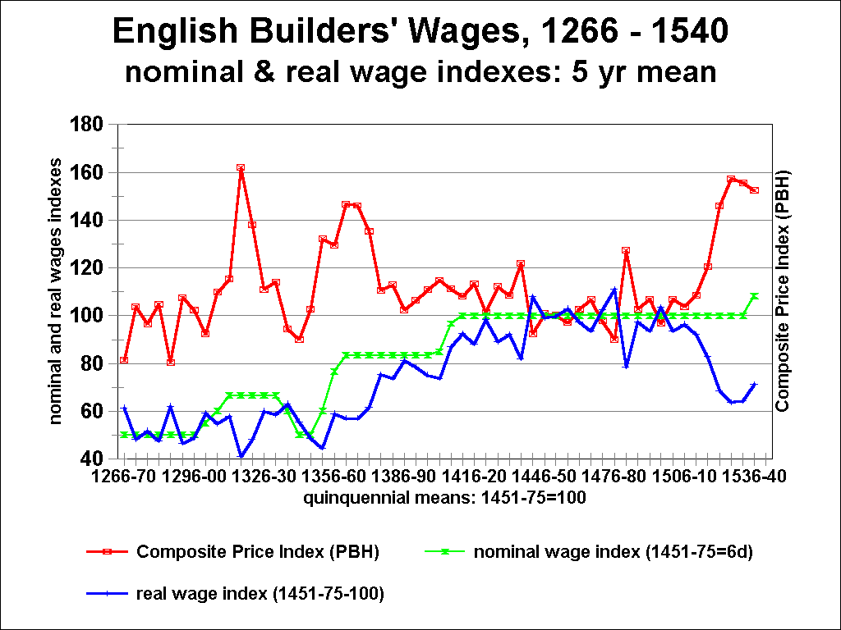

Figure 4: English Building Craftsmen’s Wages (for master masons and carpenters): 1266-70 to 1536-40, in quinquennial means: with indexes for nominal and real wages, and the composite price index. The real wage index: RWI = NWI/CPI. The nominal wage index divided by the composite price index .

Sources: E.H., Phelps Brown and Sheila V. Hopkins, ‘Seven Centuries of Building Wages,” Economica, 22:87 (August 1955), 195-206; reprinted in E.H. Phelps Brown and Sheila V. Hopkins, A Perspective of Wages and Prices (London, 1981), pp. 1-12.

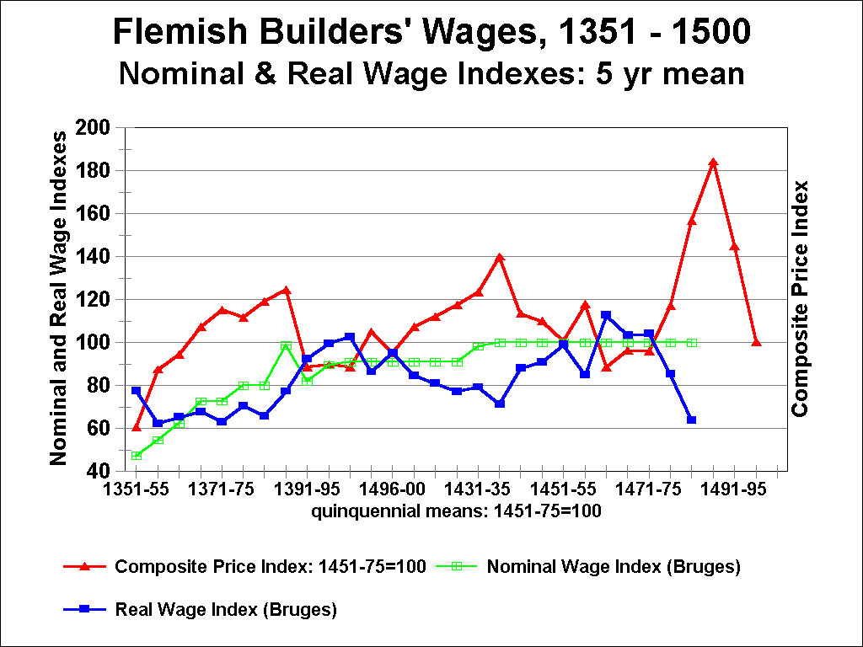

Figure 5: Flemish Building Craftsmen’s Wages (for master masons and carpenters in Bruges): 1351-55 to 1491-95, in quinquennial means: with indexes for nominal and real wages, and the composite price index. The real wage index: RWI = NWI/CPI. The nominal wage index divided by the composite price index

See the sources for Figure 1.
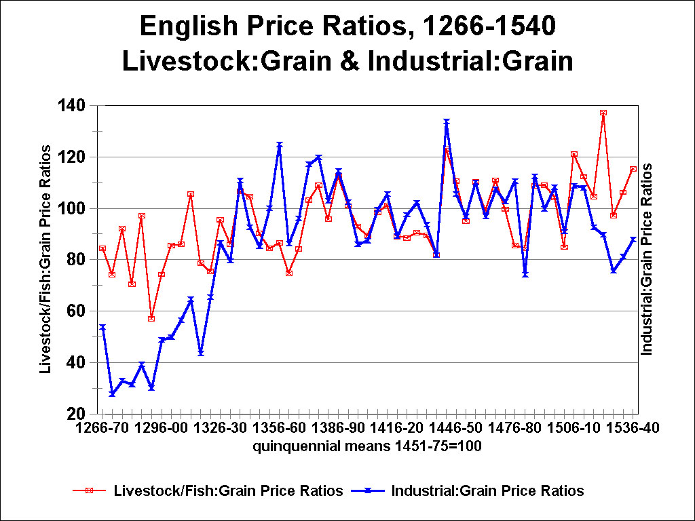

Figure 6: English Price Ratios, 1266-70 to 1536-40, in quinquennial means: (1) the ratios of livestock & fish prices to grain prices; and (2) the ratios of industrial prices to grain prices, in southern England.

See the sources for Figure 2.
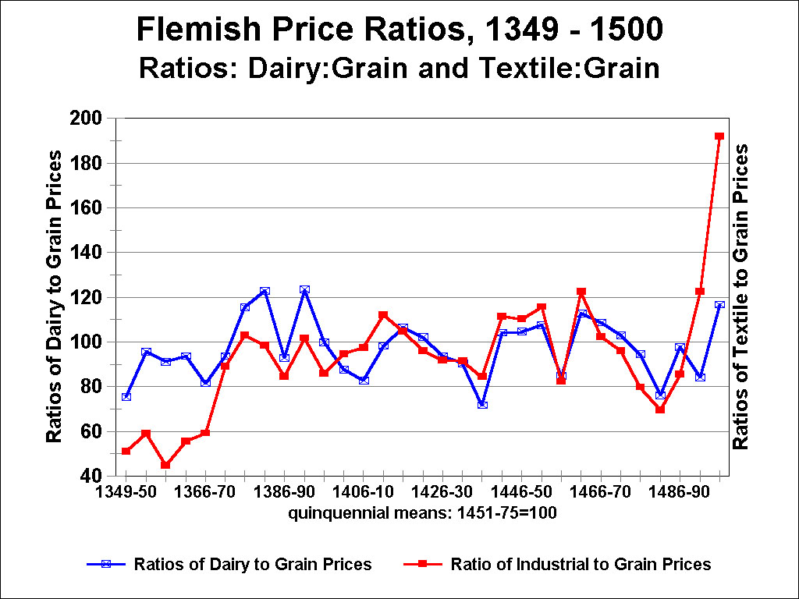

Figure 7: Flemish Price Ratios, 1266-70 to 1536-40, in quinquennial means: (1) the ratios of livestock & fish prices to grain prices; and (2) the ratios of industrial prices to grain prices, in southern England.

See the sources for Figure 1.
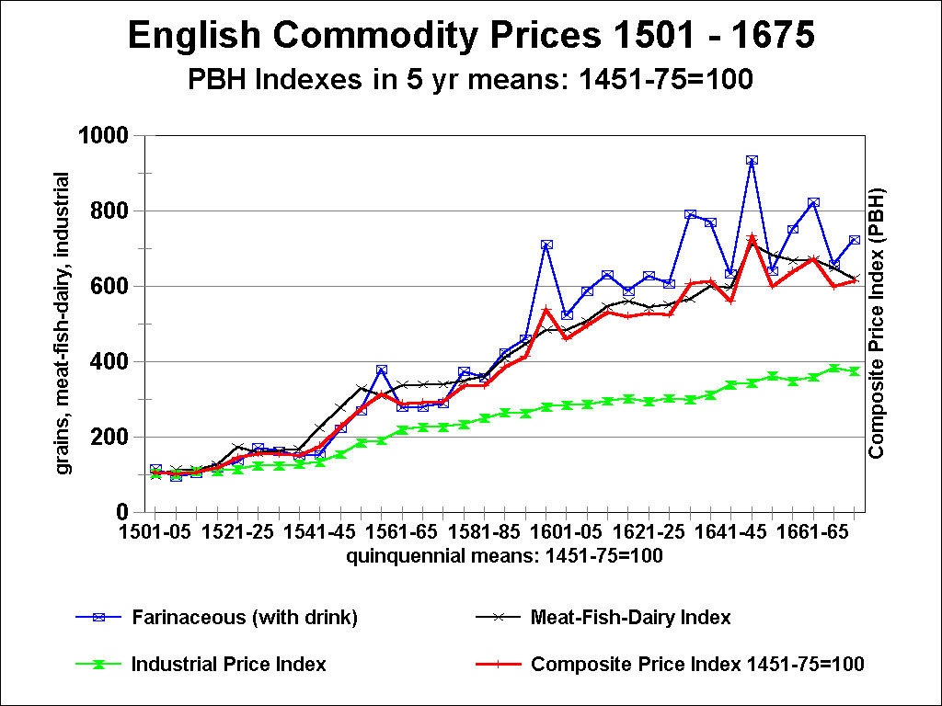

Figure 8: The Phelps Brown and Hopkins Composite Price Index for Southern England, 1501-05 to1671-75, in quinquennial means. Base: mean of 1451-75 = 100

Source: E. H. Phelps Brown and Sheila V. Hopkins, “Seven Centuries of the Prices of Consumables, Compared with Builders’ Wage-Rates,” in A Perspective of Wages and Prices (London, 1981), pp. 13-59, with price indexes for five commodity groups not given in the original publication. Their annual price data was corrected from their own working papers in: The Archives of the British Library of Political and Economic Science (Robbins Library), the Phelps Brown Papers Collection: in Boxes Ia.324 and J.IV.2a..

