Comparisons of Prices, Nominal Wages, and Real Wages in Antwerp and South-Eastern England, from 1401 to 1700, in quinquennial means

Graph no. 1

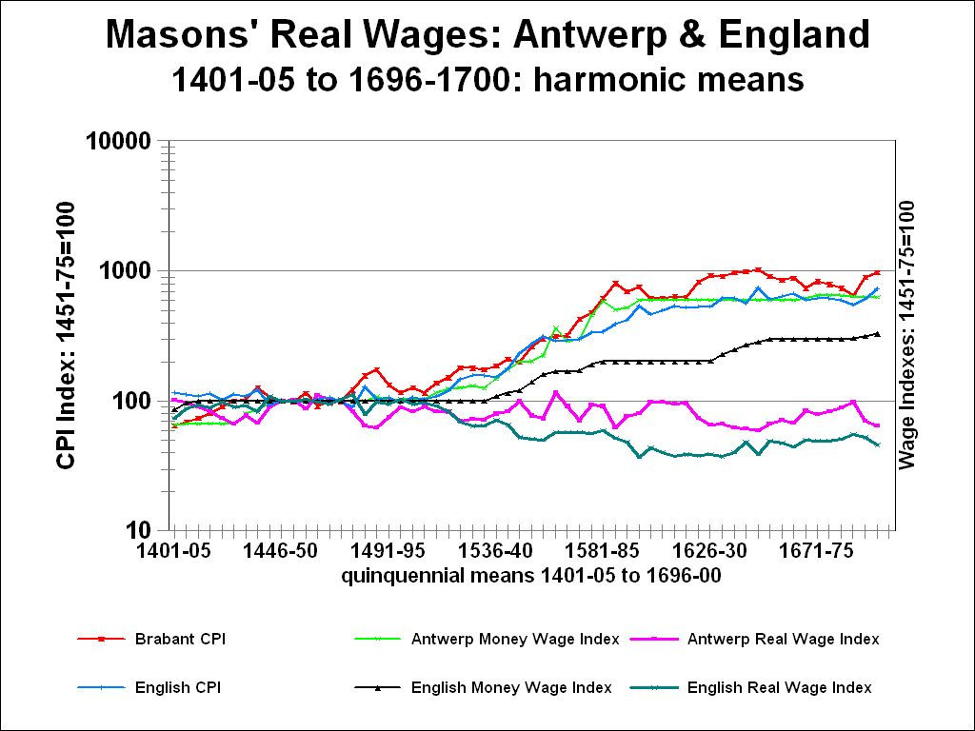

Prices and Wages, Nominal and Real, in Antwerp and South-Eastern England, 1401- 1700: semi-log scale

The Consumer Price Index (‘Basket of Consumables’), the Nominal Wage Index, and the Real Wage Index (RWI = NWI/CPI ) for Master Masons in Antwerp and towns of South-East England, in quinquennial harmonic means, for the Real Wage Index, and arithmetic means for the CPI and Nominal Wage Index, from 1401-05 to 1696-1700.

Base: 1451 – 1475 = 100
Graph no. 2

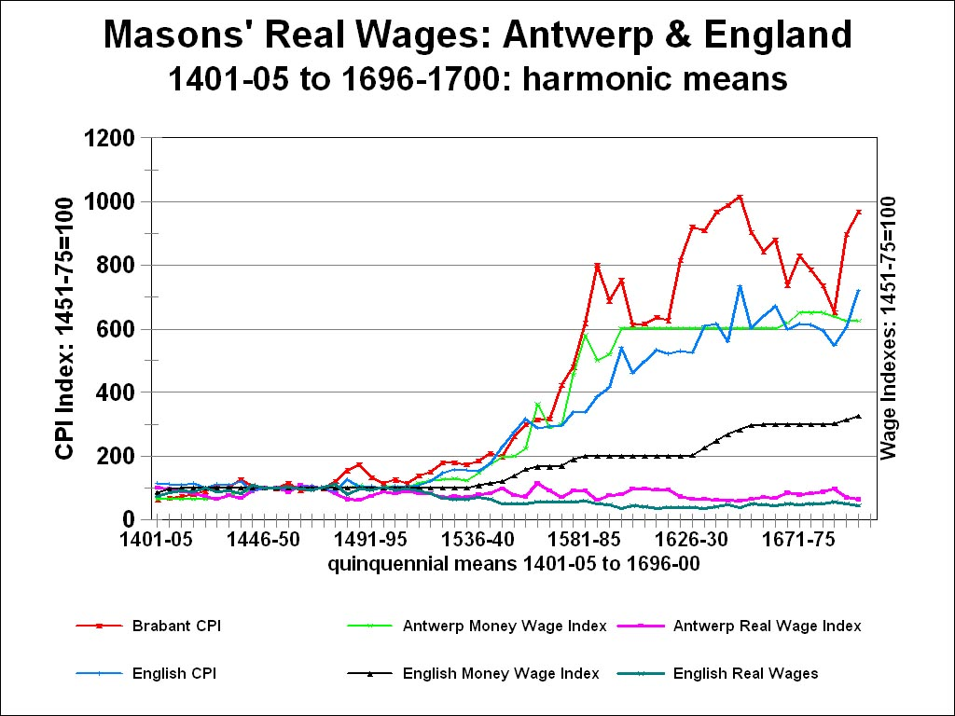

Prices and Wages, Nominal and Real, in Antwerp and South-Eastern England, 1401- 1700: arithmetic scale

The Consumer Price Index (‘Basket of Consumables’), the Nominal Wage Index, and the Real Wage Index (RWI = NWI/CPI ) for Master Masons in Antwerp and towns of South-East England, in quinquennial harmonic means, for the Real Wage Index, and arithmetic means for the CPI and Nominal Wage Index, from 1401-05 to 1696-1700.

Base: 1451 – 1475 = 100
Graph no. 3

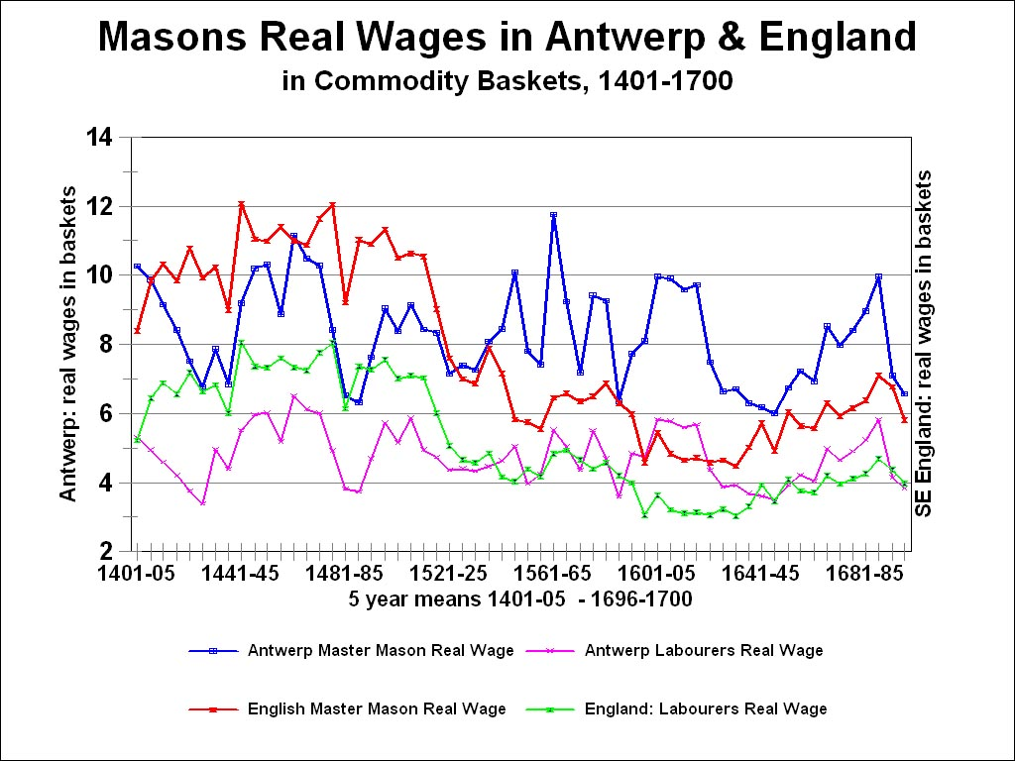

Real Wages of Master Masons and Their Labourers in Antwerp and South Eastern England, 1401 - 1700

as measured by the number of fixed commodity baskets (‘baskets of consumables’) that could have been purchased each year with the (nominal) money wage income, for 210 days employment

In quinquennial harmonic means, 1401-5 to 1696-1700

Graph no. 4

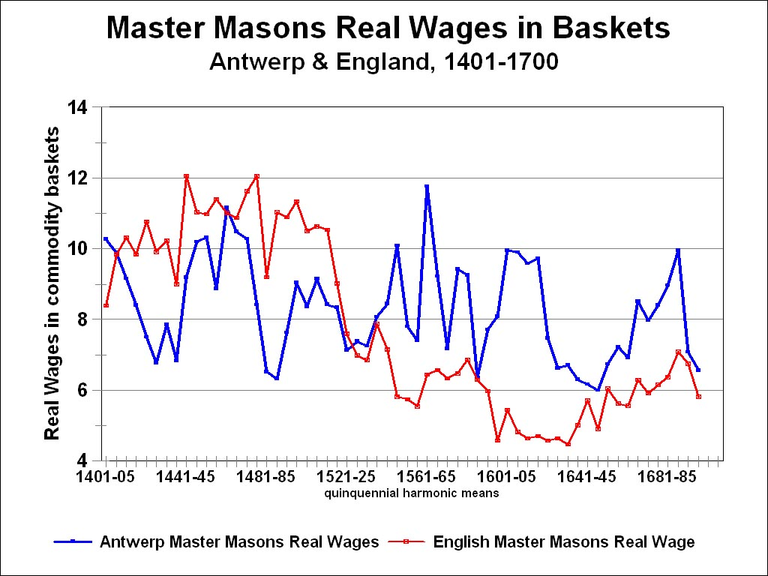

Real Wages of Master Masons in Antwerp and South Eastern England

Real wages as measured by the number of fixed commodity baskets (‘baskets of consumables’) that a master mason could have purchased each year with his (nominal) money wage income for 210 days employment.

In quinquennial harmonic means: from 1401-05 to 1696-1700.

