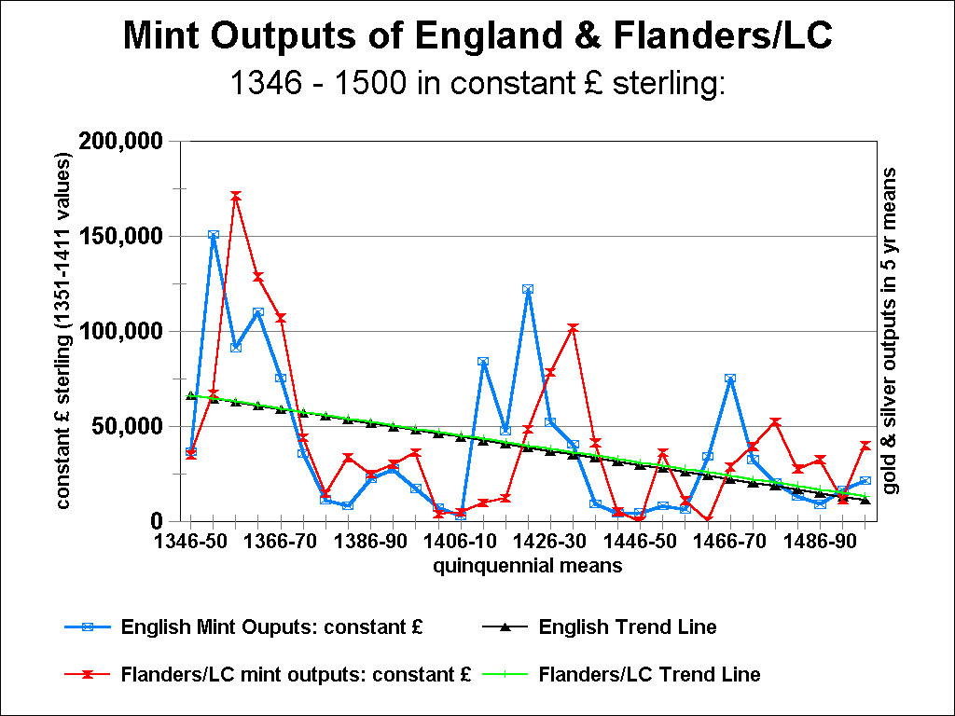
Figure 1: the Aggregate Mint Outputs (Gold and Silver) of England and the Low Countries (Flanders alone to 1384): expressed in constant values of the English pound sterling from 1351-1411
In quinquennial means: 1346-50 to 1496-1500, with least-squares regression trend lines for the mint outputs over this period.
Sources:
See the mint-account sources cited in John Munro, ‘Wage-Stickiness, Monetary Changes, and Real Incomes in Late-Medieval England and the Low Countries, 1300 - 1500: Did Money Matter?’ Research in Economic History, 21 (2003), Table 3, pp. 233-36; Table 4, pp. 237-39.
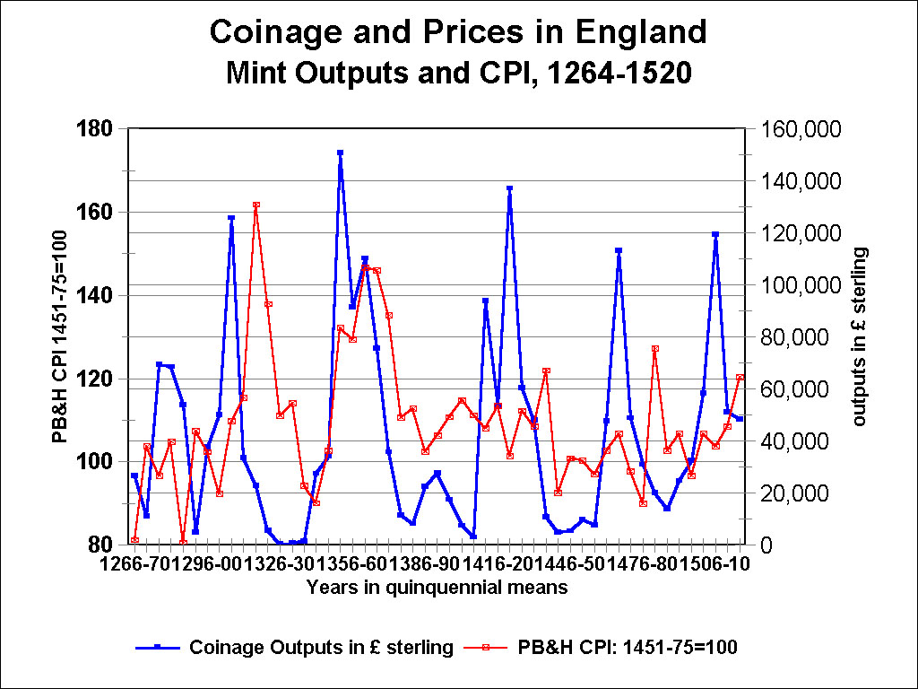
Figure 2: Coinage Outputs and Prices in England, 1266-1520
The value of aggregate mint outputs of gold and silver, in current pounds sterling, and the Phelps Brown and Hopkins Consumer Price Index (base: mean of 1451-75 = 100), in quinquennial means, from 1266-70 to 1516-20.
Sources:
John Munro, ‘Wage-Stickiness, Monetary Changes, and Real Incomes in Late-Medieval England and the Low Countries, 1300 - 1500: Did Money Matter?’ Research in Economic History, 21 (2003), Table 3, pp. 233-36; Table 4, pp. 237-39.
E. Henry Phelps Brown, and Sheila Hopkins, Centuries of the Prices of Consumables, Compared with Builders’ Wage Rates’, Economica, 23:92 (November 1956), 296-314; reprinted in E.H. Phelps Brown and Sheila V. Hopkins, A Perspective of Wages and Prices (London, 1981), pp. 13-39 (with price indexes not in the original).
Archives of the British Library of Political and Economic Science, the Phelps Brown Papers: boxes Ia:324, J.IV.2a
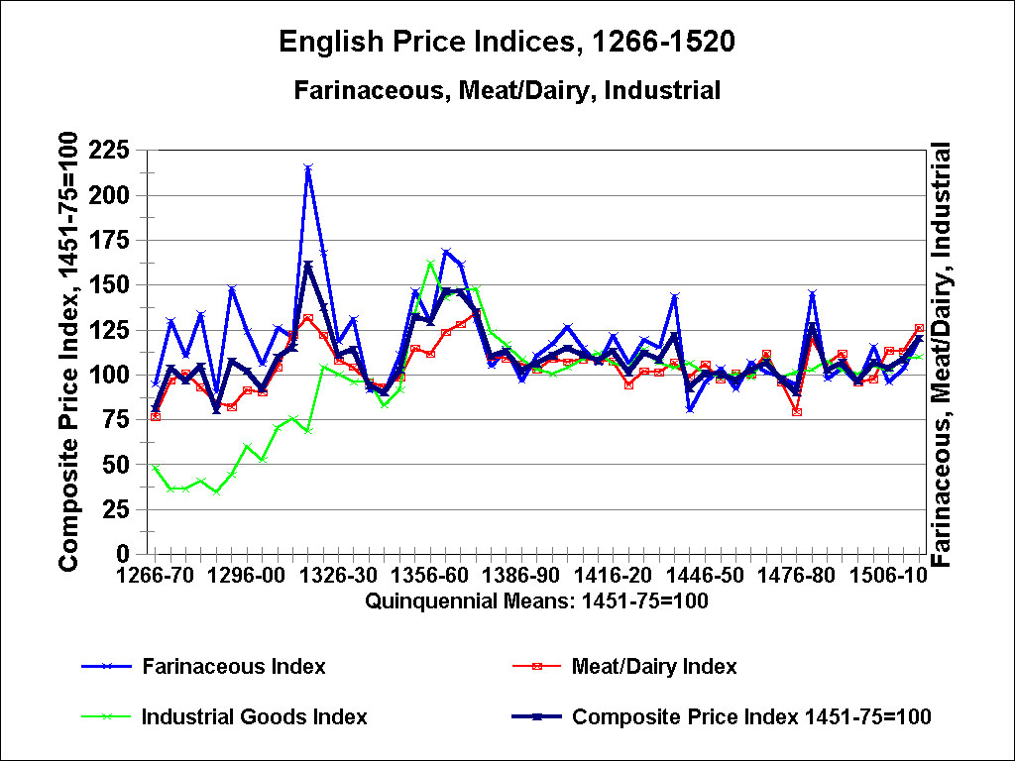
Figure 3: Medieval English Price Indices: 1266 to 1520
The Phelps Brown and Hopkins Price Index series for Farinaceous Products (wheat, rye, barly, peas), for Meat and Dairy Products, and for Industrial Goods, and their Composite Price Index, with the base: mean of 1451 – 75 = 100
In quinquennial means: from 1266-70 to 1516-20.
Sources:
E. Henry Phelps Brown, and Sheila Hopkins, Centuries of the Prices of Consumables, Compared with Builders’ Wage Rates’, Economica, 23:92 (November 1956), 296-314; reprinted in E.H. Phelps Brown and Sheila V. Hopkins, A Perspective of Wages and Prices (London, 1981), pp. 13-39 (with price indexes not in the original).
Archives of the British Library of Political and Economic Science, the Phelps Brown Papers: boxes Ia:324, J.IV.2a
Munro’s website for online research data: http://www.economics.utoronto.ca/munro5/ResearchData.html
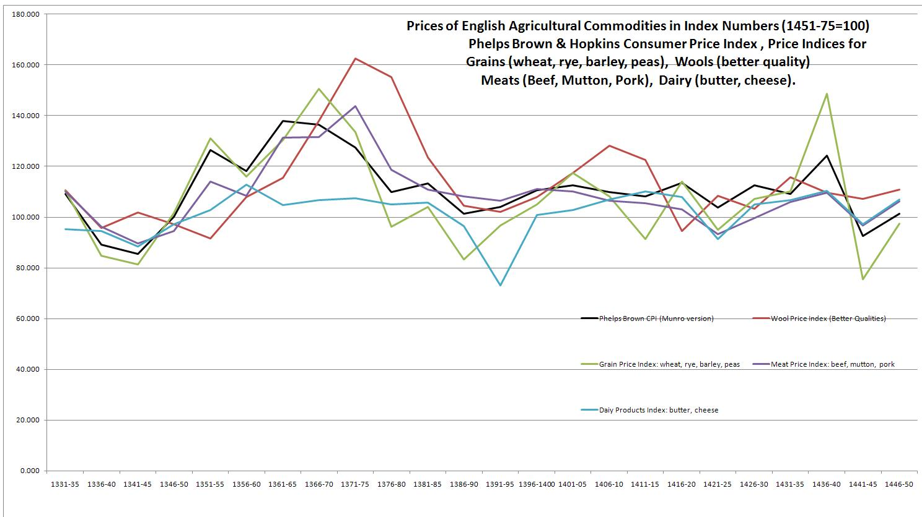
Figure 4: Prices of English Agricultural Commodities in Index Numbers (Base: 1451 – 1475 = 100), from 1331-35 to 1446-50: in quinquennial means
Price Indices for Grains (wheat, rye, barley, peas), Wools (better quality wools: exported to Calais), Meats (beef, mutton, and pork) and Dairy Products (butter and cheese), with the Phelps Brown and Hopkins Consumer Price index:
Source: Archives of the British Library of Political and Economic Science, the Phelps Brown Papers: boxes Ia:324, J.IV.2a
Munro’s website for online research data: http://www.economics.utoronto.ca/munro5/ResearchData.html
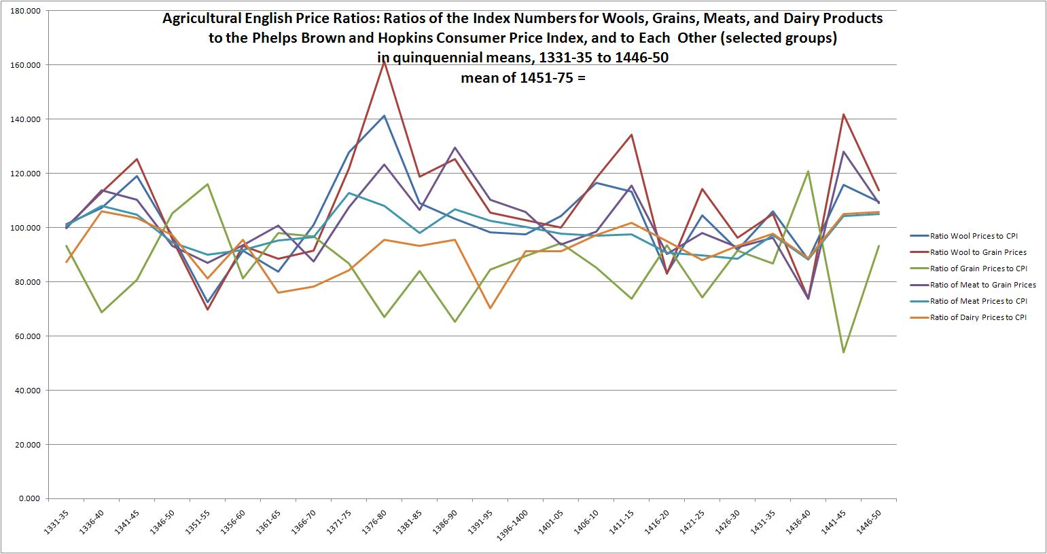
Figure 5:
English Agricultural Price Ratios: Ratios of the Index Numbers for Wools, Grains, Meats, and Dairy Products to the Phelps Brown and Hopkins Consumer Price Index, and to Each Other (in selected groups)
In quinquennial means, 1331-35 to 1446-50
Base: mean of 1451 – 75 = 100
Source: Archives of the British Library of Political and Economic Science, the Phelps Brown Papers: boxes Ia:324, J.IV.2a
Munro’s website for online research data: http://www.economics.utoronto.ca/munro5/ResearchData.html

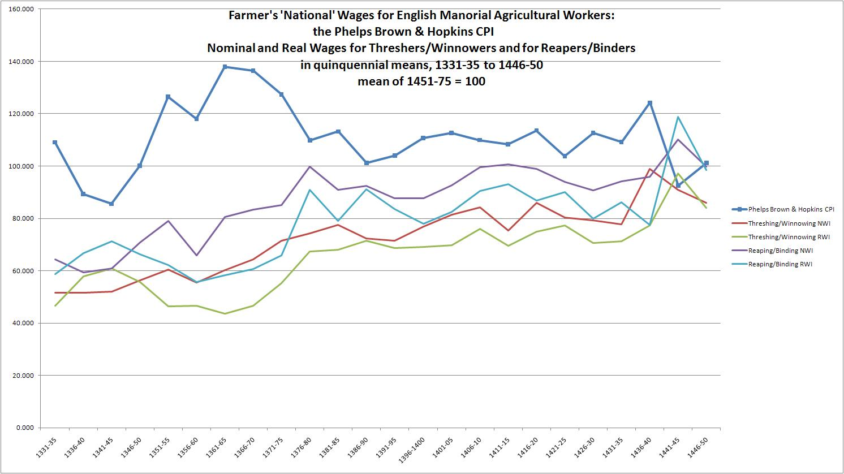

Figure 6: Farmers’ ‘National Wages’ for English Manorial Agricultural Workers, with the Phelps Brown and Hopkins Consumer Price Index
Nominal and Real Wages for Threshers/Winnowers and for Reapers/Binders
In quinquennial means, from 1331-35 to 1446-50
Base: mean of 1451-75 = 100
Sources:
(1) David Farmer, ‘Prices and Wages [1042-1350]’, in H. E. Hallam, ed., The Agrarian History of England and Wales, Vol. II: 1042-1350 (Cambridge, 1988), statistical appendixes, pp 760-78, 811-17.
David Farmer, ‘Prices and Wages, 1350-1500’, in Edward Miller, ed., The Agrarian History of England and Wales, Vol. III: 1348-1500 (Cambridge, 1991), statistical appendixes, pp.467-90, 516-24.
(2) Archives of the British Library of Political and Economic Science, the Phelps Brown Papers: boxes Ia:324, J.IV.2a
Munro’s website for online research data: http://www.economics.utoronto.ca/munro5/ResearchData.html

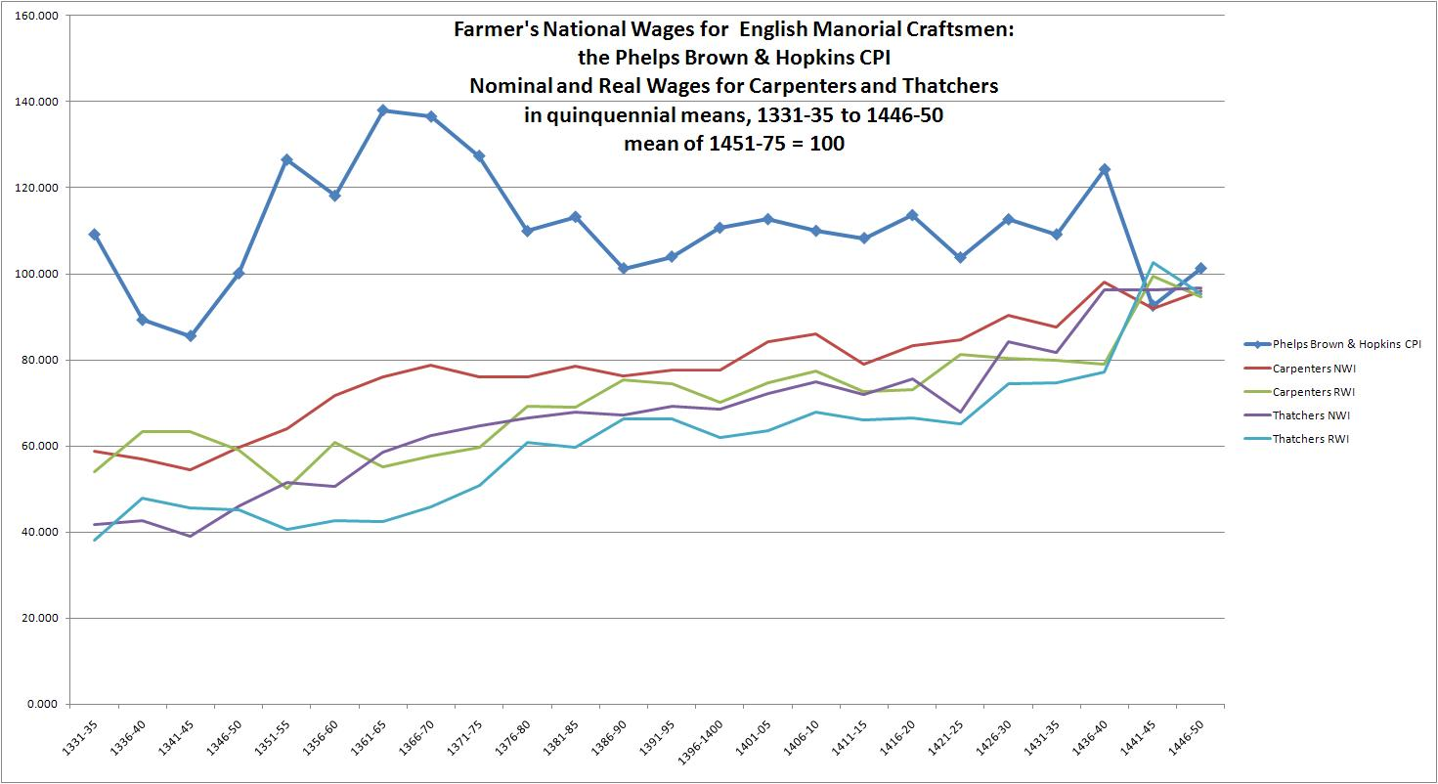

Figure 7: Farmer’s ‘National’ Wages for English Manorial Craftsmen:
Nominal and Real Wage Indexes for Carpenters and Thatchers, with the Phelps Brown and Hopkins Consumer Price Index
In quinquennial means: from 1331-35 to 1446-50
Base: mean of 1451-75 = 100
Sources:
(1) David Farmer, ‘Prices and Wages [1042-1350]’, in H. E. Hallam, ed., The Agrarian History of England and Wales, Vol. II: 1042-1350 (Cambridge, 1988), statistical appendixes, pp 760-78, 811-17.
David Farmer, ‘Prices and Wages, 1350-1500’, in Edward Miller, ed., The Agrarian History of England and Wales, Vol. III: 1348-1500 (Cambridge, 1991), statistical appendixes, pp.467-90, 516-24.
(2) Archives of the British Library of Political and Economic Science, the Phelps Brown Papers: boxes Ia:324, J.IV.2a
Munro’s website for online research data: http://www.economics.utoronto.ca/munro5/ResearchData.html
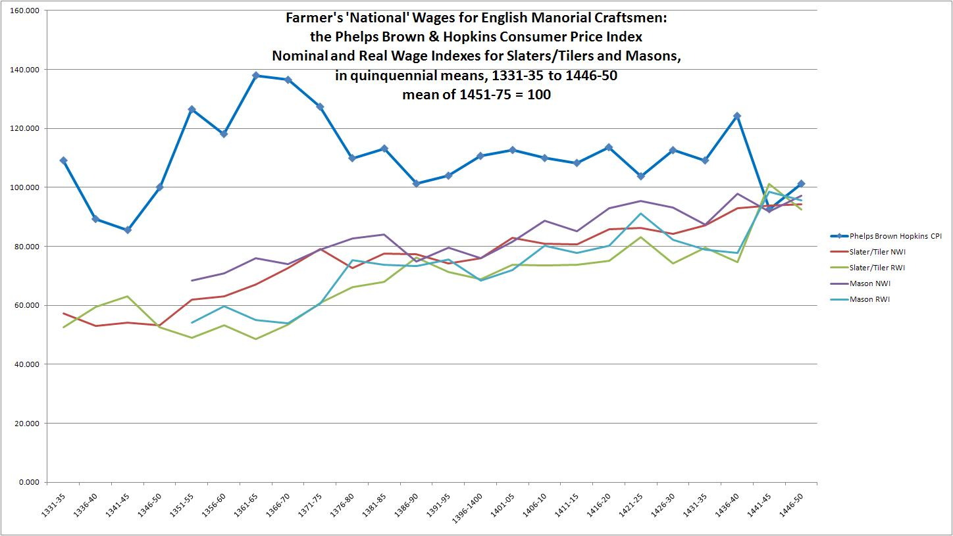

Figure 8: Farmer’s ‘National Wages’ for English Manorial Craftsmen:
Nominal and Real Wage Indexes for Slaters/Tilers and Masons, with the Phelps Brown and Hopkins Consumer Price Index
In quinquennial means, from 1331-35 to 1446-50
Sources:
(1) David Farmer, ‘Prices and Wages [1042-1350]’, in H. E. Hallam, ed., The Agrarian History of England and Wales, Vol. II: 1042-1350 (Cambridge, 1988), statistical appendixes, pp 760-78, 811-17.
David Farmer, ‘Prices and Wages, 1350-1500’, in Edward Miller, ed., The Agrarian History of England and Wales, Vol. III: 1348-1500 (Cambridge, 1991), statistical appendixes, pp.467-90, 516-24.
(2) Archives of the British Library of Political and Economic Science, the Phelps Brown Papers: boxes Ia:324, J.IV.2a
Munro’s website for online research data: http://www.economics.utoronto.ca/munro5/ResearchData.html
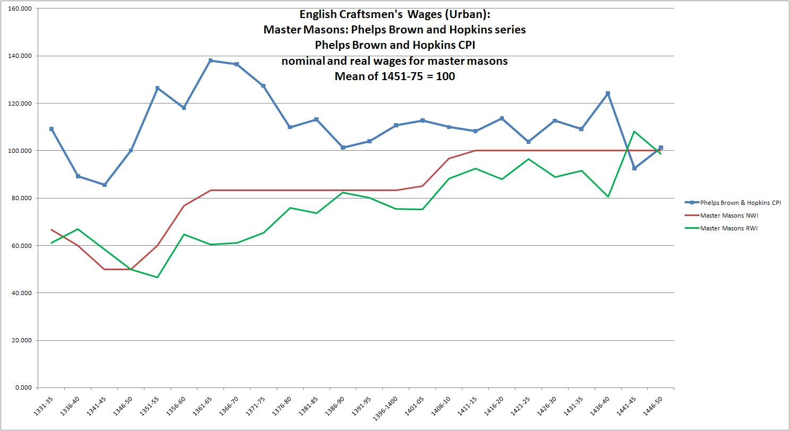

Figure 9: English Urban Craftsmen’s Wages (Oxford-Cambridge region and small towns of SE England)
Nominal and Real Wages for Master Masons, with the Phelps Brown and Hopkins Consumer Price Index
In quinquennial means: 1331-35 to 1446-50
Base: mean of 1451-75 = 100
Source: Archives of the British Library of Political and Economic Science, the Phelps Brown Papers: boxes Ia:324, J.IV.2a
Munro’s website for online research data: http://www.economics.utoronto.ca/munro5/ResearchData.html
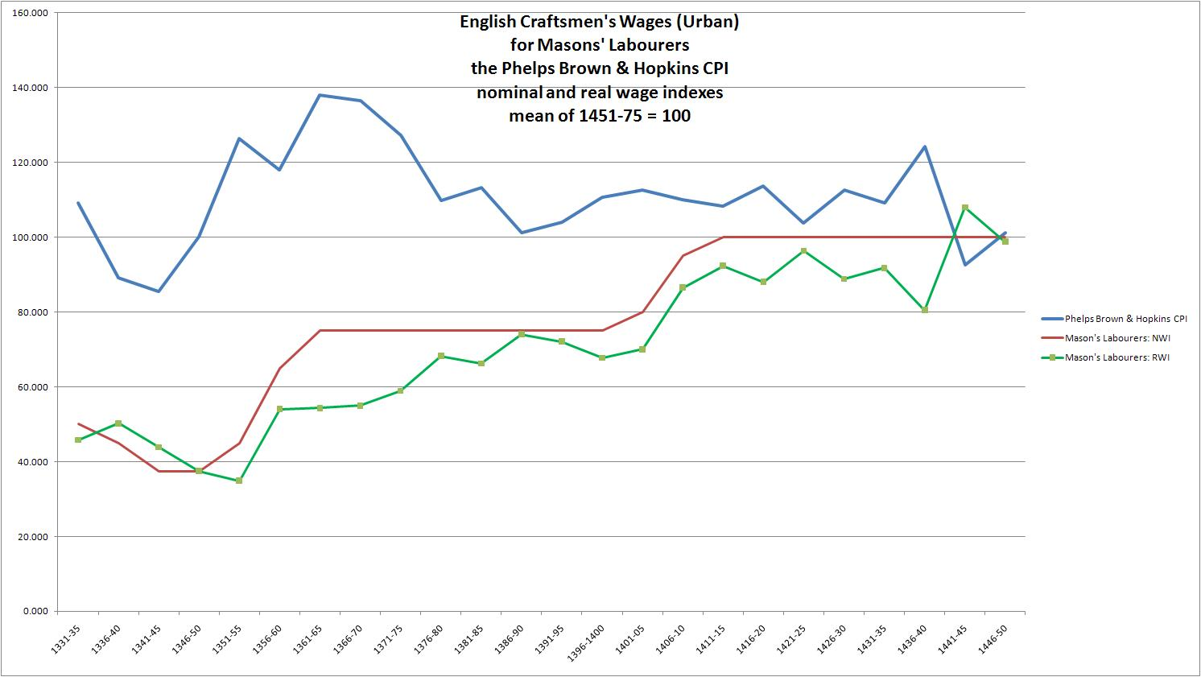
Figure 10: English Urban Craftsmen’s Wages (Oxford-Cambridge region and small towns of SE England)
Real and Nominal Wage Indexes for Masons’ Labourers and the Phelps Brown and Hopkins Consumer Price Index
Source: Archives of the British Library of Political and Economic Science, the Phelps Brown Papers: boxes Ia:324, J.IV.2a
Munro’s website for online research data: http://www.economics.utoronto.ca/munro5/ResearchData.html

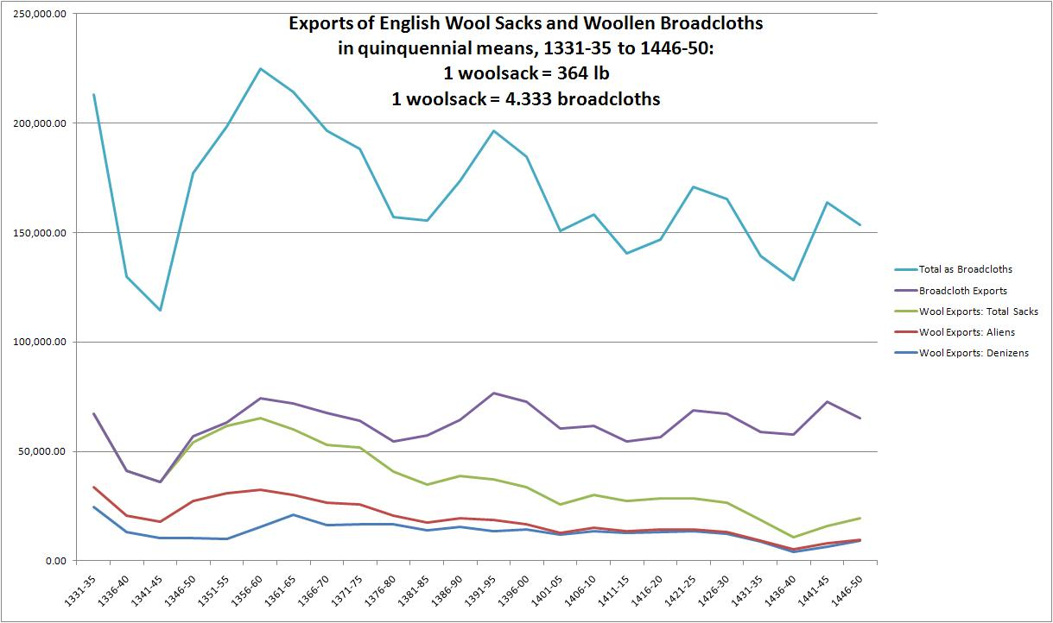

Figure 11: Exports of English Wool Sacks and Woollen Broadcloths (and equivalent textiles)
In quinquennial means, from 1331-35 to 1446-50
One woolsack = 364 lb (165.108 kg) = 4.333 broadcloths of assize (24 yards by 1.75 yd)
Sources:
Eleanor M. Carus Wilson and Olive Coleman, eds., England’s Export Trade, 1275-1547 (Oxford, 1963), pp. 36-119; A.R. Bridbury, Medieval English Clothmaking: An Economic Survey (London, 1982), Appendix F, pp. 118-22
Munro’s website for online research data: http://www.economics.utoronto.ca/munro5/ResearchData.html
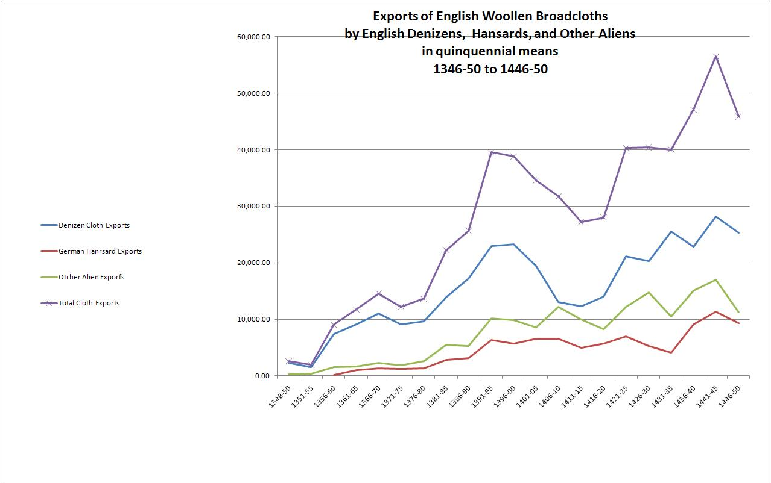
Figure 12: Exports of English Woollen Broadcloths (and equivalents), by English Denizens, German Hansards, and Other Aliens
In quinquennial means, from 1331-35 to 1446-50
Sources:
E.M. Carus Wilson and Olive Coleman, eds., England’s Export Trade, 1275-1547 (Oxford, 1963), pp. 36-119; A.R. Bridbury, Medieval English Clothmaking: An Economic Survey (London, 1982), Appendix F, pp. 118-22
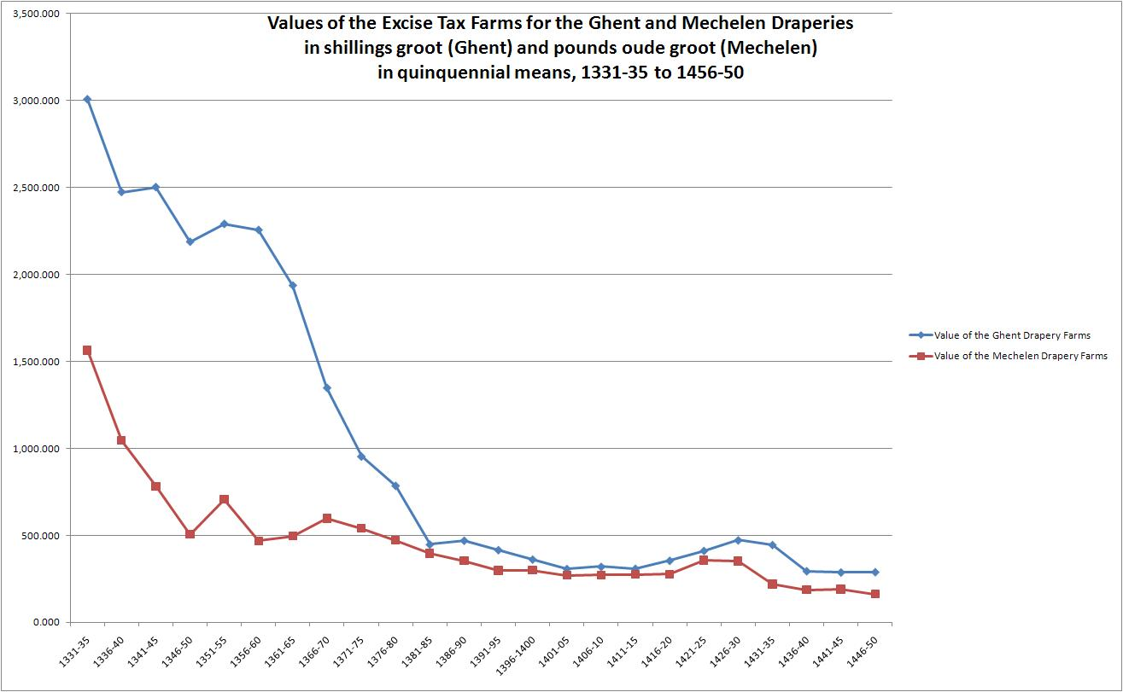

Figure 13: The Values of the Excise Tax Farms for the Woollen Draperies of Ghent (Flanders) and Mechelen (Brabant)
In shillings groot Flemish for Ghent, and pounds oude groot for Mechelen
In quinquennial means, 1331-35 to 1446-50
Sources:
Ghent A: Total drapery excise farms; Ghent B: Excises for ‘Ramen en Nieuwe Huusgeld’ only: all from: Stadsarchief Gent, Stadsrekeningen, Reeks 400:4-43, 1335-1520; Algemeen Rijksarchief België, Rekenkamer, reg. nos. 38,635-72;
Mechelen: Stadsarchief Mechelen, Stadsrekeningen, 1316-1550, Series I: nos. 3-225; Algemeen Rijksarchief, Rekenkamer, reg. nos. 41,219-85;
Munro’s website for online research data: http://www.economics.utoronto.ca/munro5/ResearchData.html
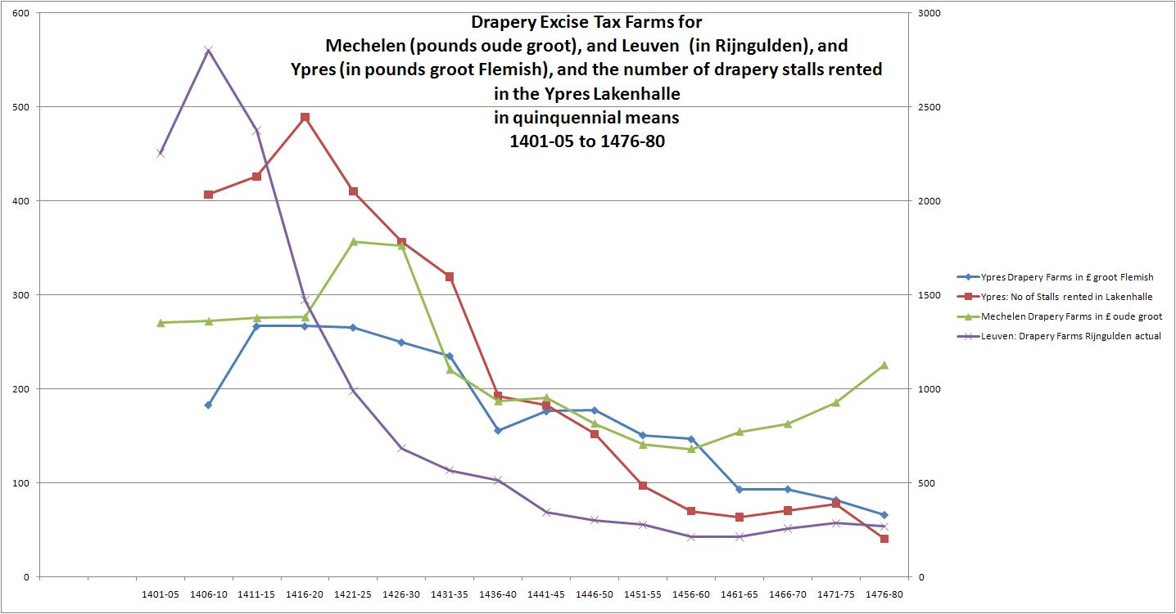
Figure 14: Cloth Production in the Fifteenth-Century Southern Low Countries
The Drapery Excise Tax Farms for Mechelen (in pounds oude groot), Leuven (in Rijngulden), and Ypres (in pounds groot Flemish), with the number of drapery stalls rented in the Ypres Lakenhalle,
In quinquennial means, from 1401-05 to 1476-80.
Sources:
Ypres: Algemeen Rijksarchief België, Rekenkamer, reg. nos. 38,636-722.
Mechelen: Stadsarchief Mechelen, Stadsrekeningen, 1316-1550, Series I: nos. 3-225; Algemeen Rijksarchief, Rekenkamer, reg. nos. 41,219-85;
Leuven: Stadsarchief Leuven, Stadsrekeningen, 1345-1500, nos. 4986-5124.
Munro’s website for online research data: http://www.economics.utoronto.ca/munro5/ResearchData.html

