Figure 1.

The prices and relative values of Ghent dickedinnen broadcloths, as purchased for the burgermasters and aldermen of the Ghent civic government, from 1331 to 1570:

expressed in terms of the Flemish pound (£) groot (20 shillings to the pound); and in terms of the Commodity Price Indexes of Flanders (1351-1500) and Brabant (1401-1570), with the Nominal and Real Price Indexes for Ghent dickedinnen broadcloths,
in quinquennial means, 1331-35 to 1566-70.

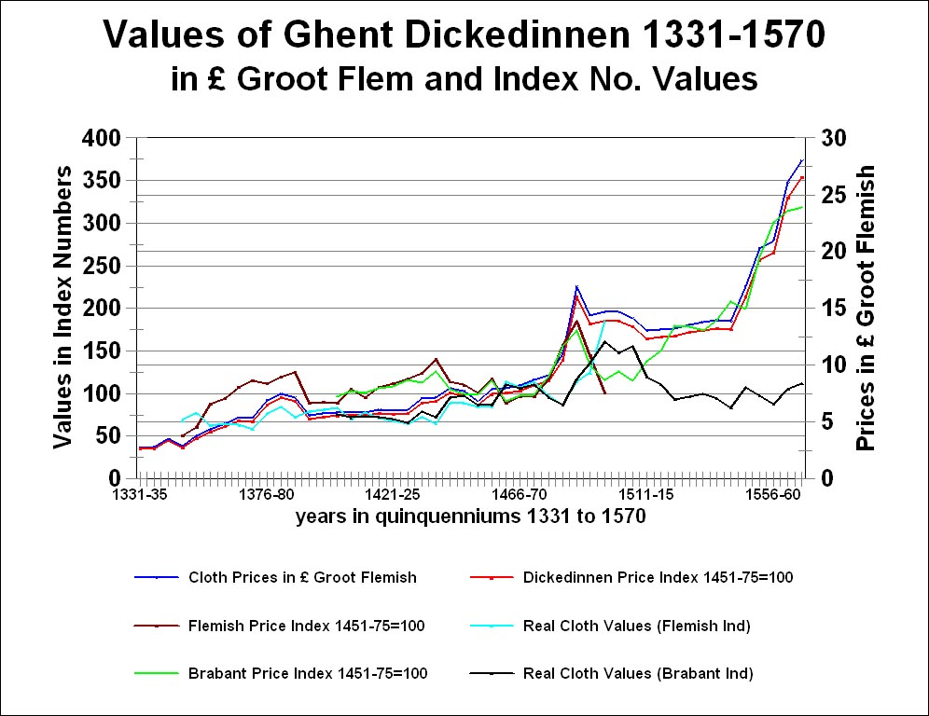
Figure 2.

The Value of Ghent dickedinnen broadcloths, 1331 – 1570, in quinquennial means, as purchased for the burgermasters and aldermen of the Ghent civic government

The nominal and real price indexes for the Ghent dickedinnen broadcloths: based on the Flemish Commodity Price Index (1351-1500) and Brabant (1501-1570).

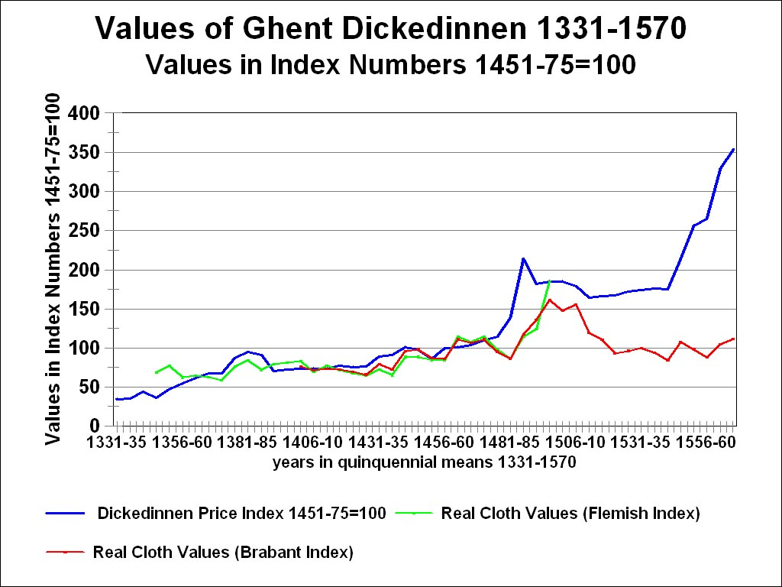
Figure 3.

The Prices and relative values of Ghent dickedinnen broadcloths, 1331 – 1570, in quinquennial means, as purchased for the burgermasters and aldermen of the Ghent civic government

Prices in pounds groot Flemish (20s = £1 = 240d)

The nominal and real price indexes for the Ghent dickedinnen broadcloths: based on the Flemish Commodity Price Index (1351-1500)

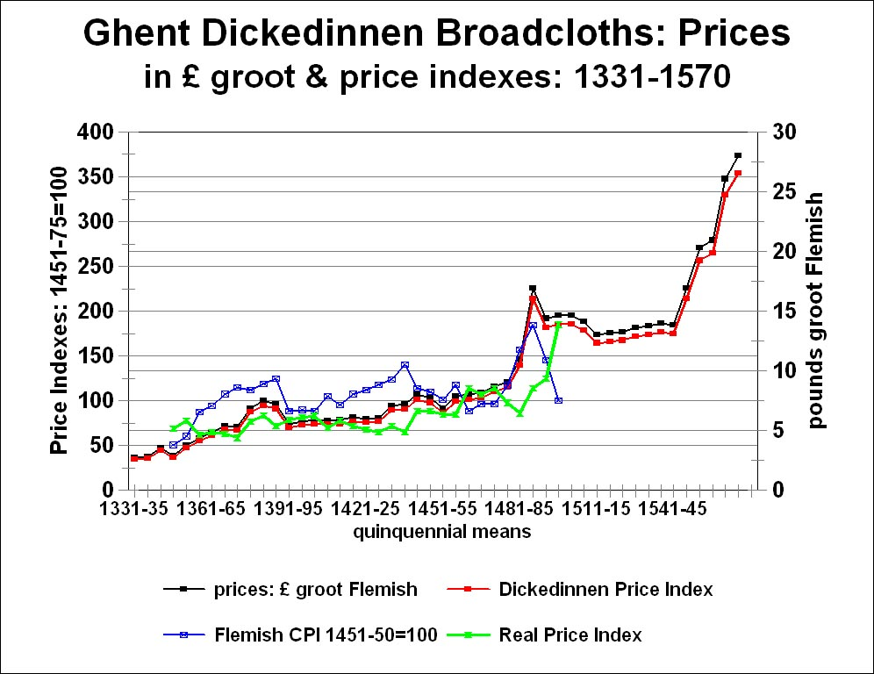
Figure 4.

The Values of Ghent dickedinnen broadcloths purchased for the burgermasters and aldermen of the Ghent civic government, from 1331 to 1500, in relation to a master mason’s daily wage, in quinquennial means:

The number of days’ wages that a Bruges master mason would have had to spend to buy one of these broadcloths.

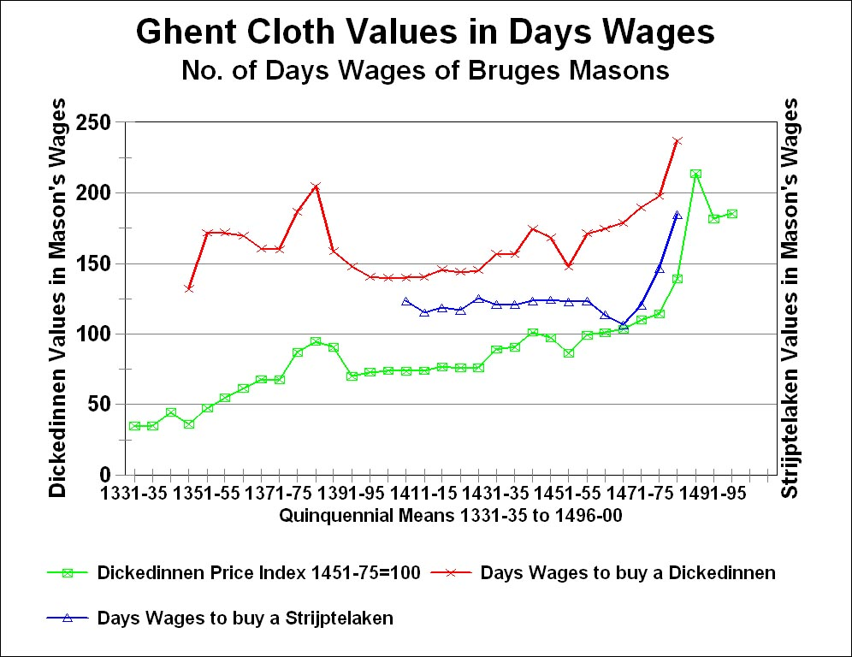
Figure 5.

The Values of Ghent dickedinnen broadcloths purchased for the burgermasters and aldermen of the Ghent civic government, from 1401 to 1570, in relation to a master mason’s daily wage, in quinquennial means:

The number of days’ wages that an Antwerp master mason would have had to spend to buy one of these broadcloths.

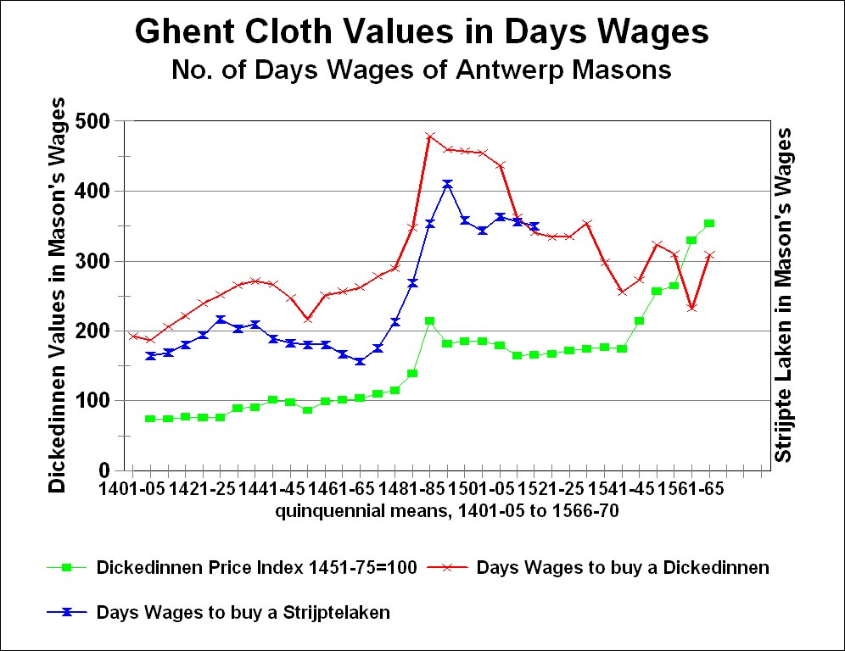
Figure 5:

The relative values of Ghent dickedinnen broadcloths, as purchased for the bugermasters and aldermen of the Ghent civic government, from 1331 to 1570: in quinquennial harmonic means.

The number of Flemish Commodity Baskets (‘Baskets of Consumables’) equal to the value of a single Ghent dickedinnen broadcloth, 1331-1500, and the number of Brabantine (Antwerp) Commodity Baskets equal to the value of a single Ghent dickedinnen broadcloth, fromm 1401 to 1570.

With the Flemish and Brabantine Commodity Price Indexes.

