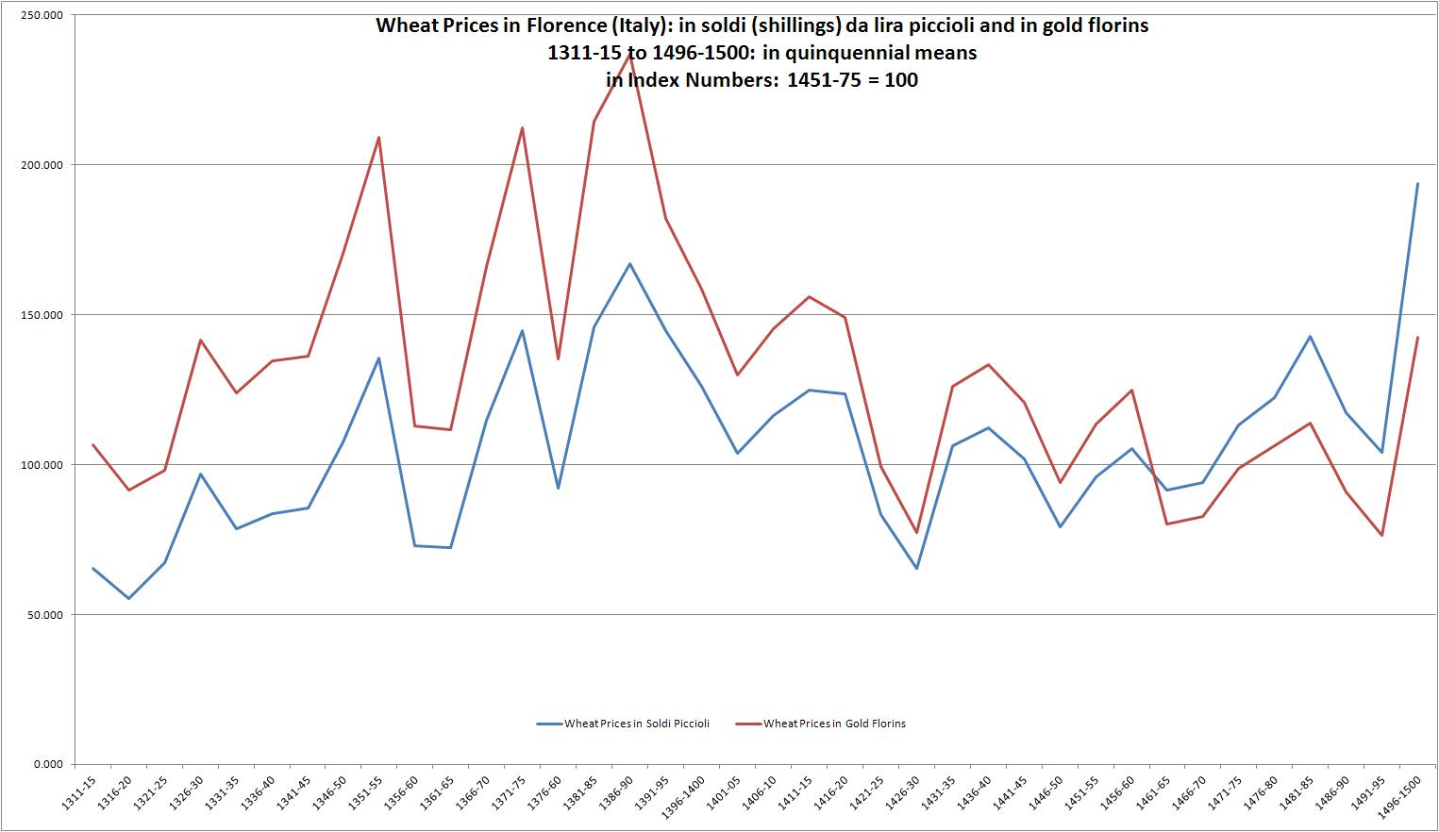
Wheat Prices in Florence (Italy): expressed in the silver-based money of account, the lira di piccioli (in soldi) and in gold florins:
Prices in quinquennial means, 1311-15 to 1496-1500
In index numbers: base 1451 – 75 = 100
Prices are for staio of wheat: 1 staio = 25.92 litres = 0.73 bushel
Source: Sergio Tognetti, ‘Prezzi e salari nella Firenze tardomedievale: un profilo’, Archivio storico italiano, 153: 564 (1995), 263-333: Table A1, pp. 317-18.

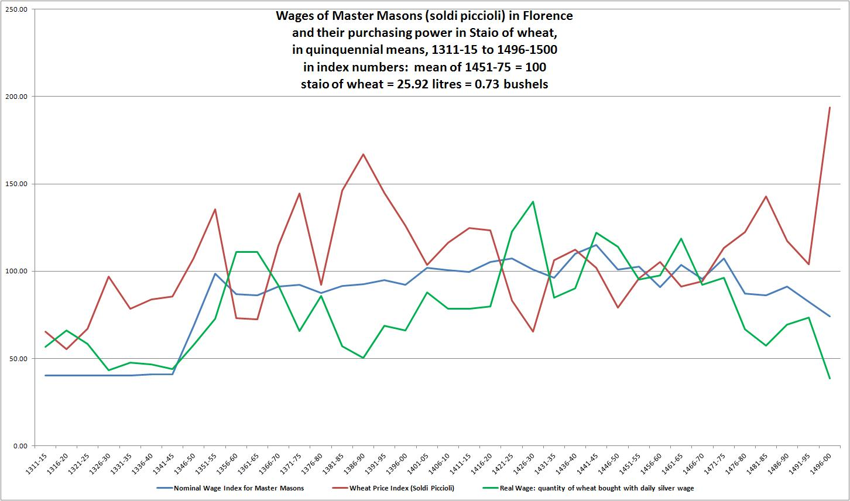

Wages Master Masons in Florence:
Wages in the silver-based money of account, the lira di piccioli,
And in the purchasing power of those wages (real wages): the number of staio of wheat that could be purchased with the daily wage for master mason
1 staio = 25.92 litres = 0.73 bushels
In quinquennial means: 1311-15 to 1495-1500
In index numbers: base 1451 – 75 = 100
Sources:
Sergio Tognetti, ‘Prezzi e salari nella Firenze tardomedievale: un profilo’, Archivio storico italiano, 153: 564 (1995), 263-333: Table A1, pp. 317-18.
Paolo Malanima's Tables on Prices and Wages in Italy, 1270 - 1913: available in a Word file online at:
http://www.economics.utoronto.ca/munro5/StatResources.htm

