Price Relatives for Fuels (Wood, Charcoal and Coal) and
the Phelps Brown and Hopkins 'Basket of Consumables'
(Revised Version)

1451-60 to 1781-90, in decennial means

Base (1) 1451 - 1475 = 100 Base (2) 1581-90 = 100

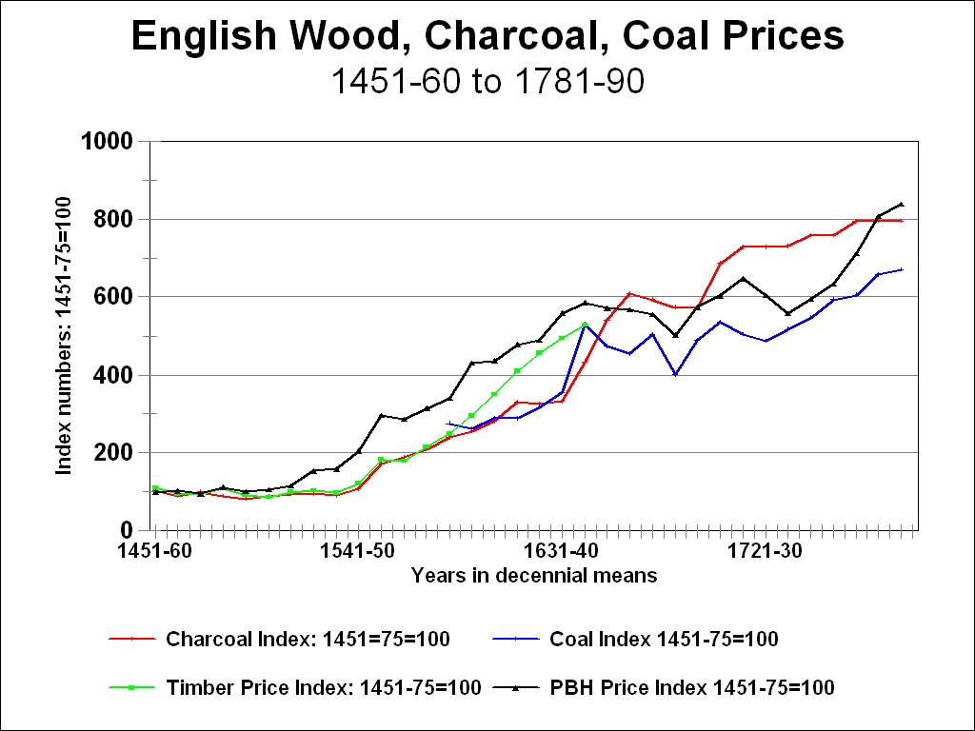

Sources:

The Phelps Brown Papers Collection, Archives of the British Library of Political and Economic Science (LSE Archives);

Peter Bowden, ‘Agricultural Prices, Farm Profits, and Rents’, in Joan Thirsk, ed., The Agrarian History of England and Wales, Vol. IV: 1500 - 1640 (Cambridge: Cambridge University Press, 1967), Table VI, pp. 846-850.

I have converted his original base, 1450-99= 100 (7.99s for 100 faggots) to the PBH base of 1451-75.

