ENGLAND AND THE LOW COUNTRIES, 1336 – 1500:

REAL WAGES FOR CRAFTSMEN AND LABOURERS IN COMMODITY BASKETS PURCHASED WITH ANNUAL MONEY-WAGE INCOMES

Figure 5

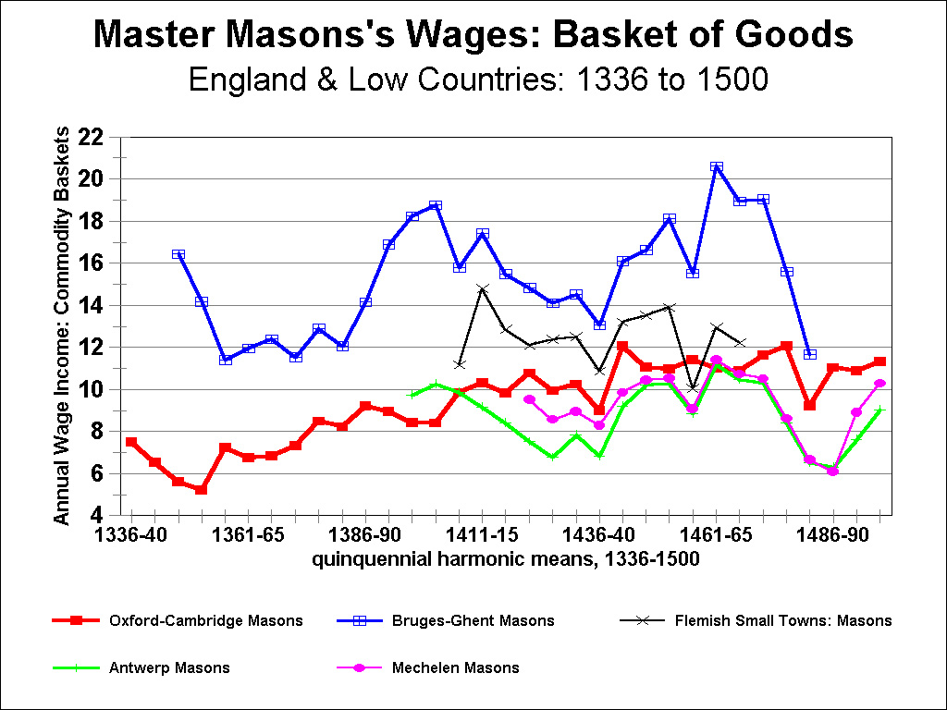
ENGLAND AND THE LOW COUNTRIES, 1336 – 1500:

REAL WAGES FOR CRAFTSMEN AND LABOURERS IN COMMODITY BASKETS PURCHASED WITH ANNUAL MONEY-WAGE INCOMES

Figure 6

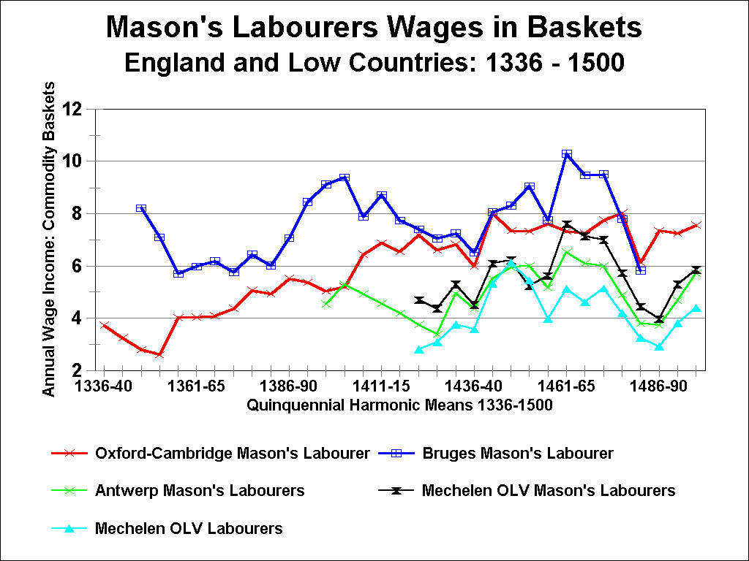

ENGLAND AND THE LOW COUNTRIES, 1336 – 1500:

REAL WAGES FOR CRAFTSMEN AND LABOURERS IN COMMODITY BASKETS PURCHASED WITH ANNUAL MONEY-WAGE INCOMES

Figure 6

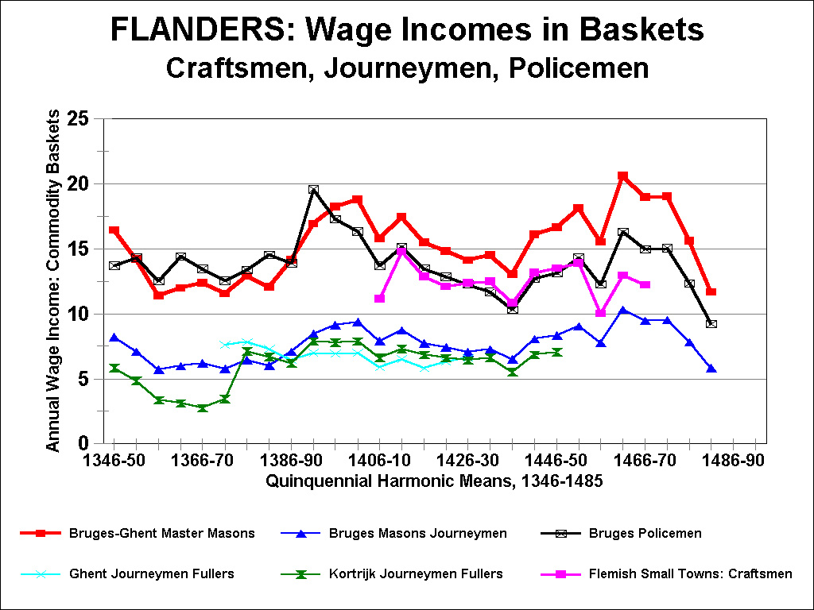
ENGLAND AND THE LOW COUNTRIES, 1336 – 1500:

REAL WAGES FOR CRAFTSMEN AND LABOURERS IN COMMODITY BASKETS PURCHASED WITH ANNUAL MONEY-WAGE INCOMES

Figure 7

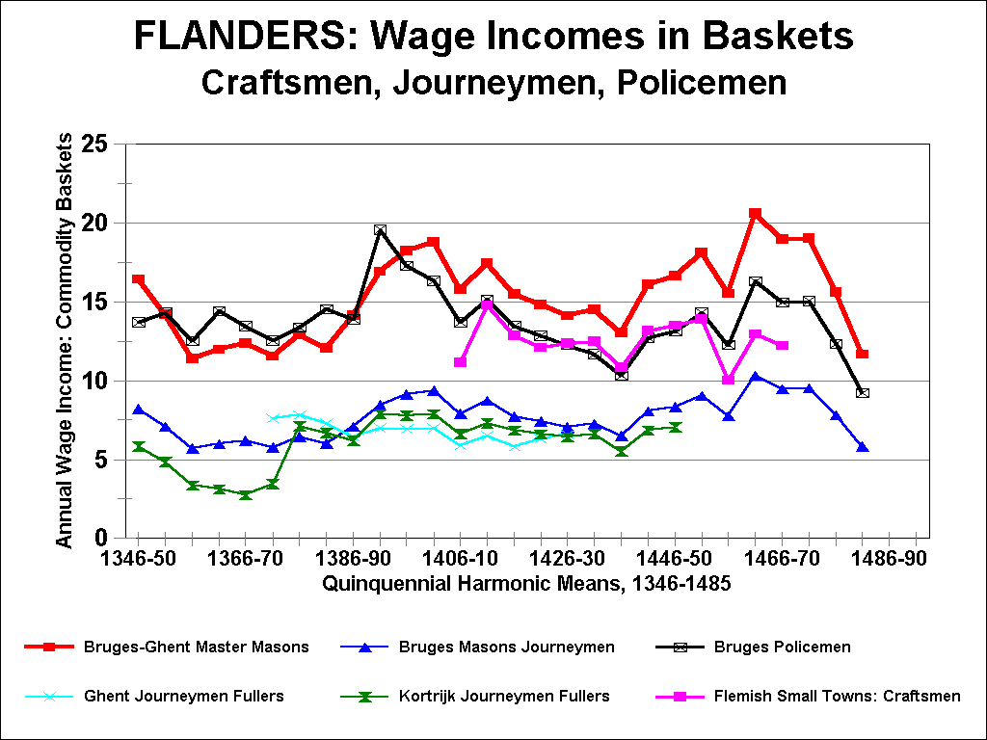
ENGLAND AND THE LOW COUNTRIES, 1336 – 1500:

REAL WAGES FOR CRAFTSMEN AND LABOURERS IN COMMODITY BASKETS PURCHASED WITH ANNUAL MONEY-WAGE INCOMES

Figure 8

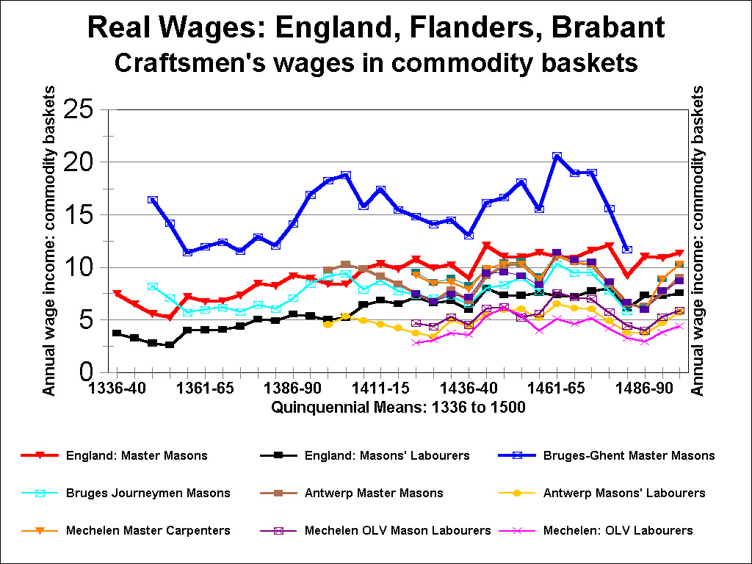
ENGLAND AND THE LOW COUNTRIES, 1336 – 1500:

REAL WAGES FOR CRAFTSMEN AND LABOURERS IN COMMODITY BASKETS PURCHASED WITH ANNUAL MONEY-WAGE INCOMES

Figure 9

