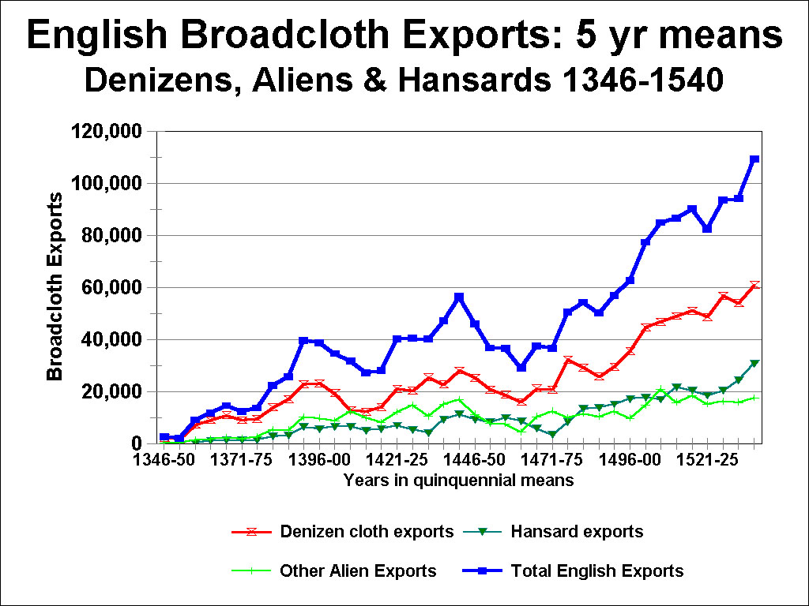
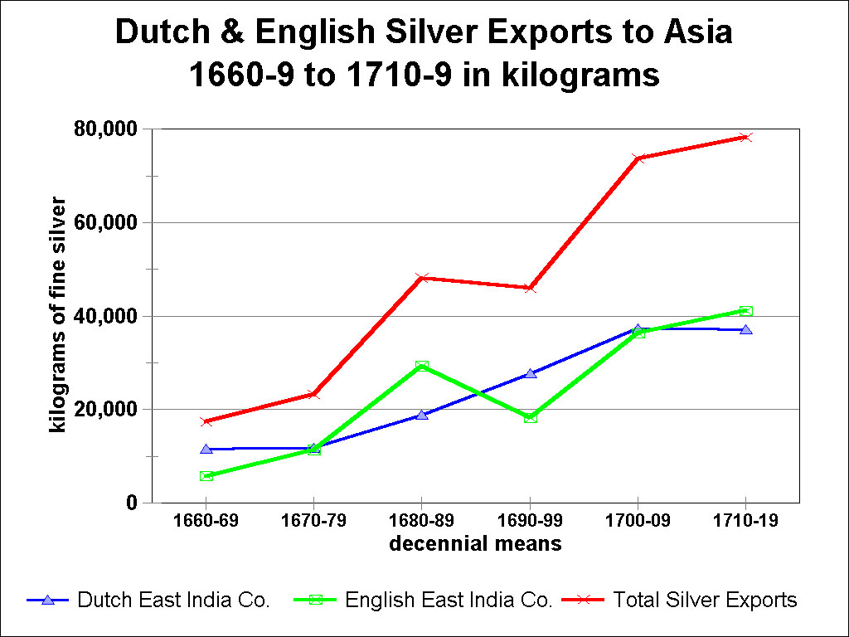
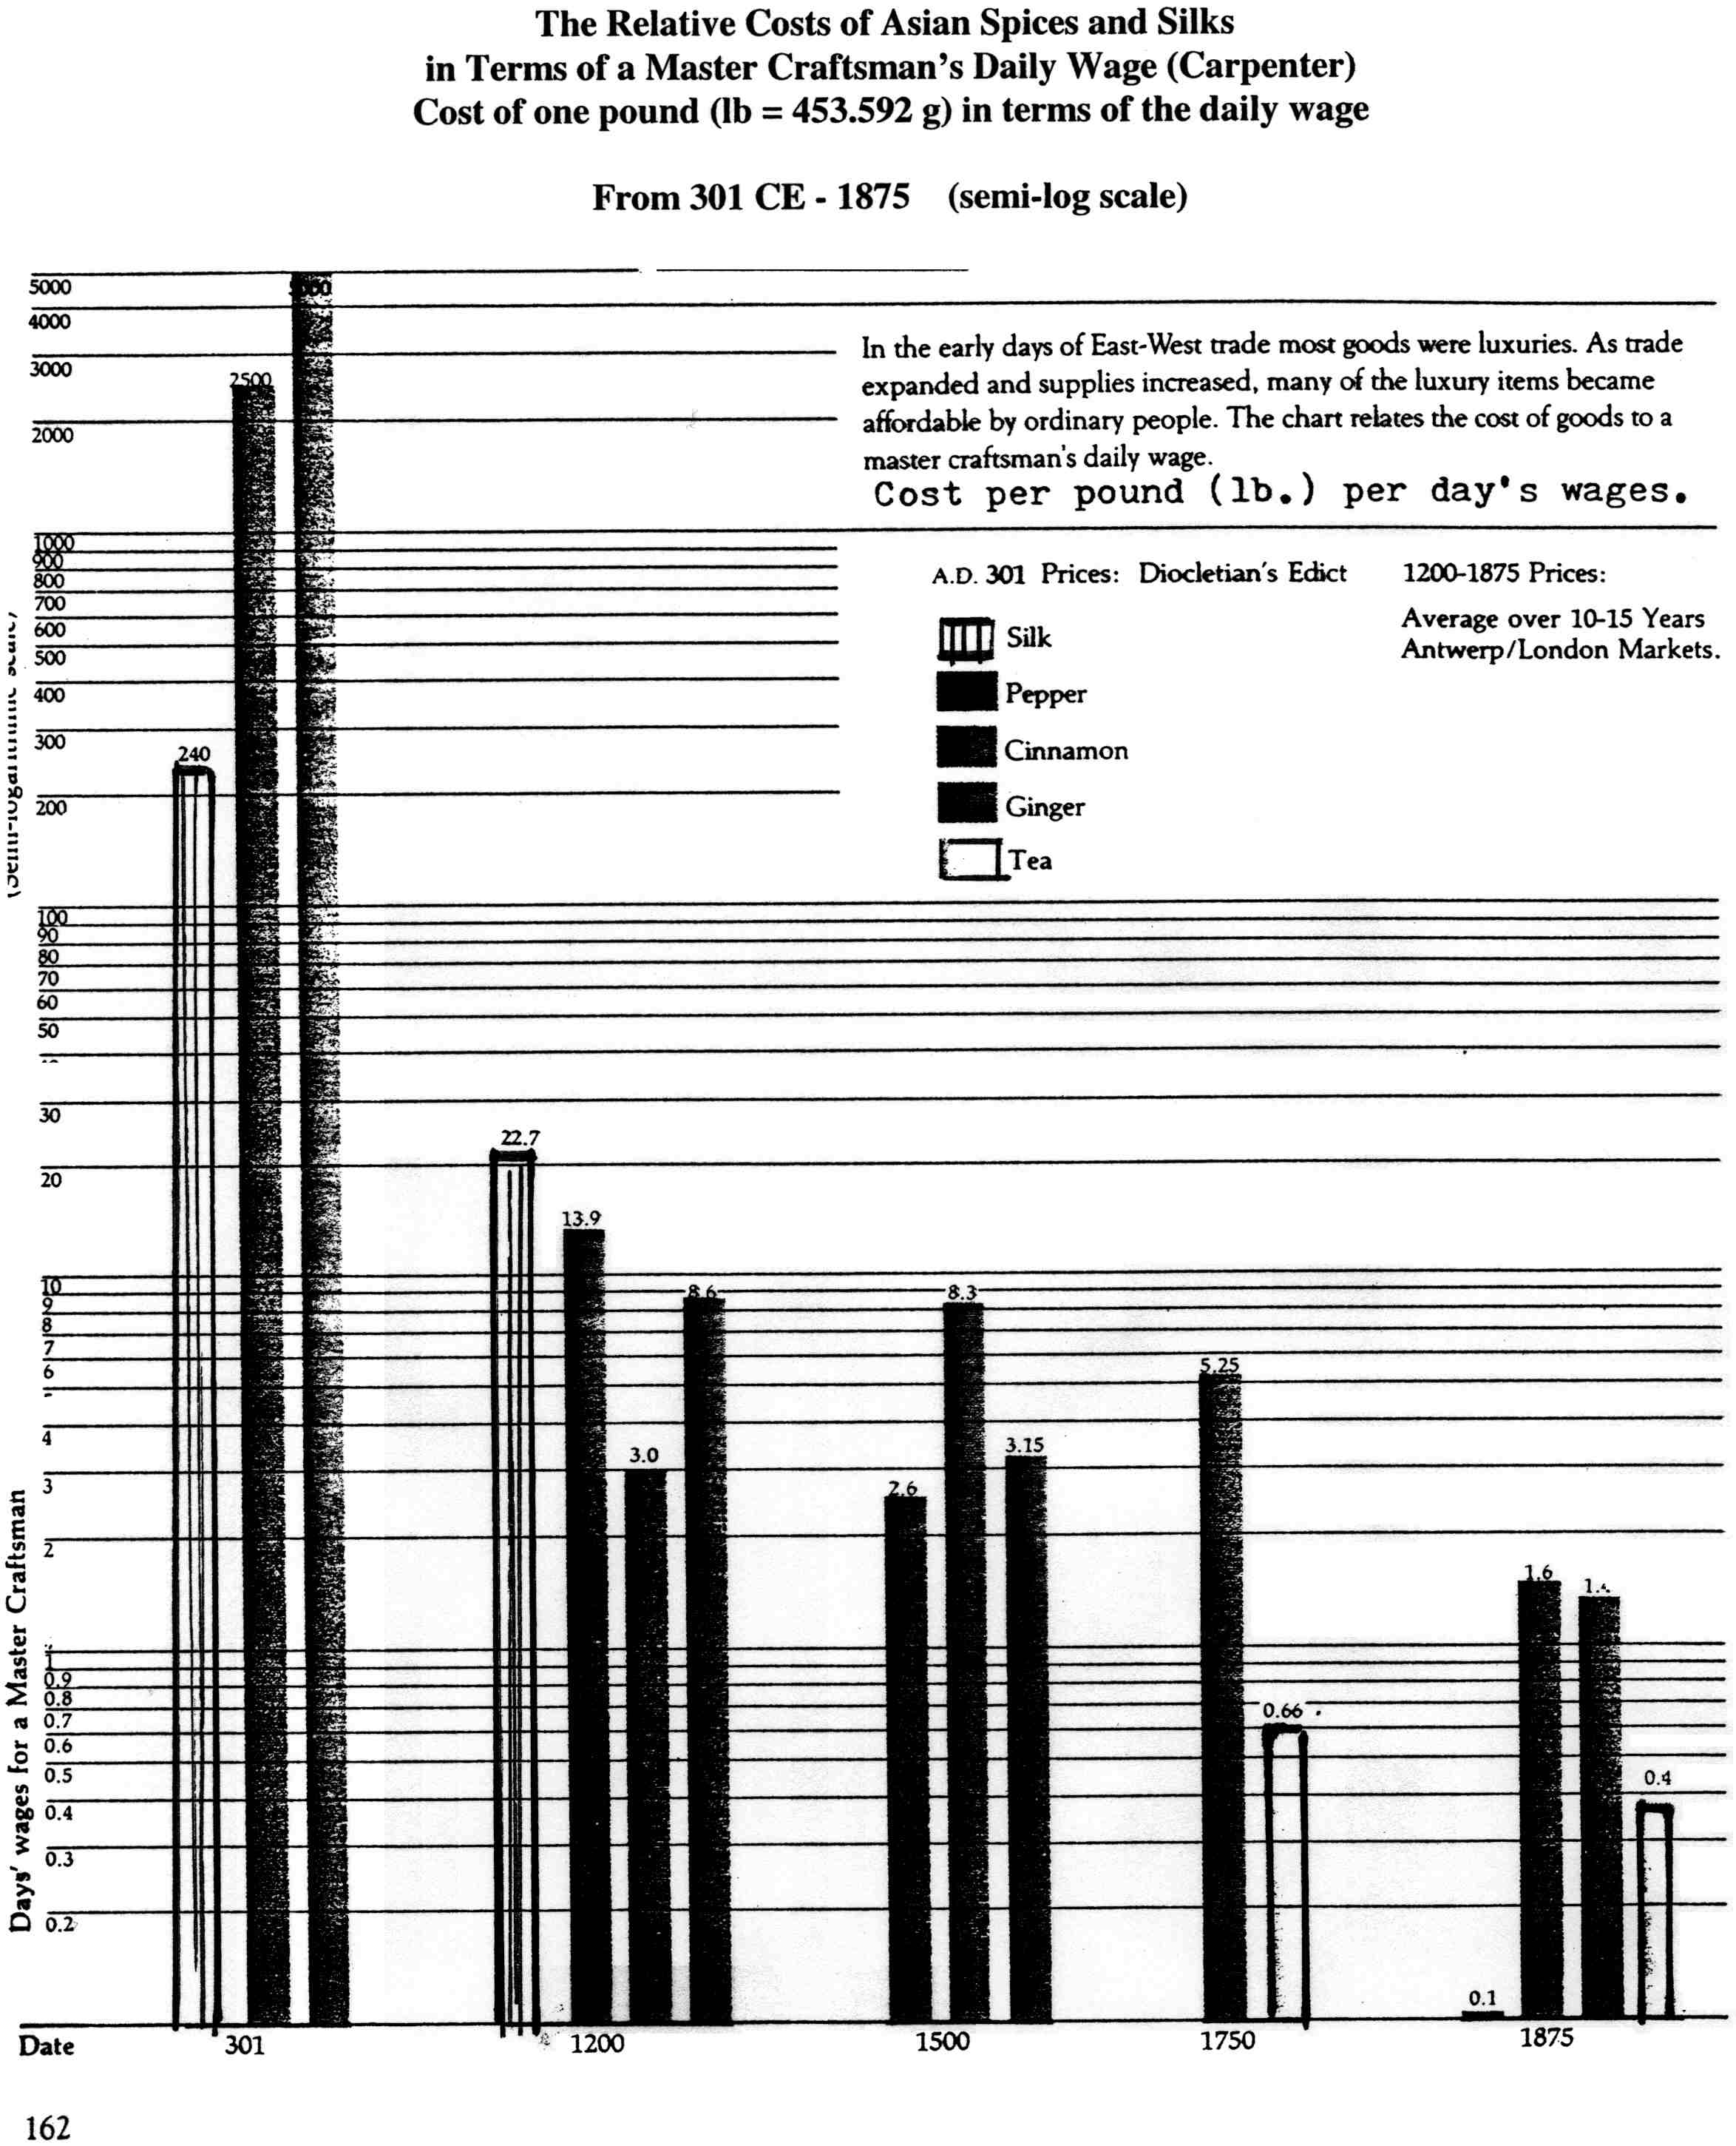
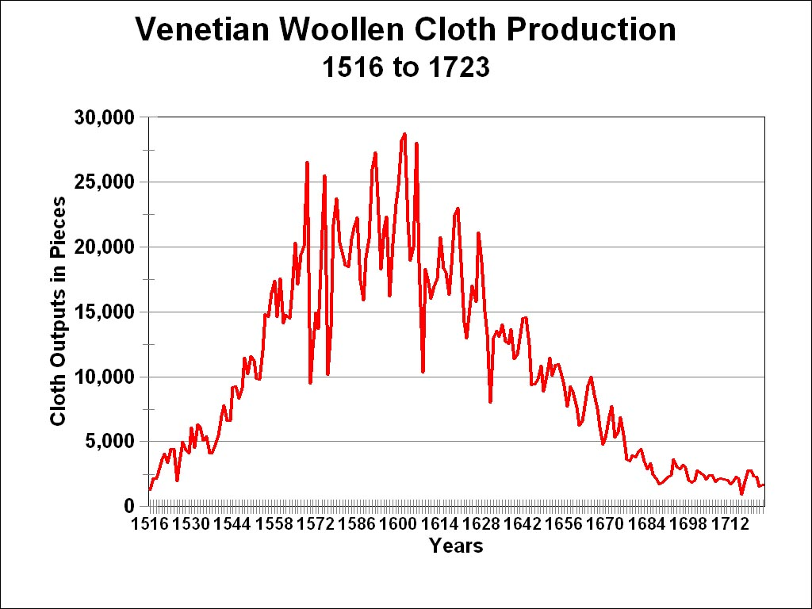

Sources:

Walter Panciera, L=Arte matrice: I lanifici della Repubblica di Venezia nei secoli XVII e XVIII, Studi veneti, no. 5 (Treviso: Fondazione Benetton Studi Ricerche and Canova Editrice, 1996), Table 2, pp. 42-43, which also extends the series from 1713 to 1723. I wish to offer my sincere thanks to Professor Panciera, who sent me a photo-copy of the document from the Venetian archives (ASCW, Cinque savi b. 476) containing the original data. His table corrects many errors that had been reproduced in the much better know series of statistics on Venetian woollen cloth production, in Domenico Sella, >Rise and Fall of the Venetian Woollen Industry=, in Brian Pullan, ed., Crisis and Change in the Venetian Economy in the Sixteenth and Seventeenth Centuries (London, 1968), pp. 106-26; translated by the author, in a revised and expanded form, from >Les mouvements longs de l'industrie lainière à Venise=, Annales: Économies, sociétés, civilisations, 12 (1957), 29 - 45. Unfortunately, I found it necessary to correct his statistics, from the original archival document, for the following four years: 1521, 1618, 1639, 1662.
